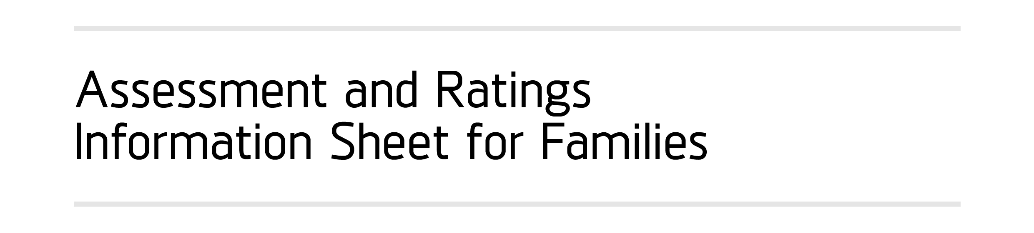
Please delete the word “sample” and print on service letterhead after adapting the text below to suit your service.

Dear Parent
Our service has recently been assessed under the new National Quality Framework introduced across Australia from 1 January 2012, and I am writing to share the results of this assessment with you.
Many of you will be aware that on 1 January 2012 the Federal Government introduced new quality standards that a service must meet, as a part of the National Quality Framework. The following is a brief outline about the new system:
- This system is uniform across Australia and is designed to improve the quality of education and care for all Australian children.
- It applies to most types of early learning services such as Long Day Care (LDC), Family Day Care (FDC), kindergartens, and Out of School Hours Care (OSHC).
- This is the first time that kindergartens have been assessed against a set of quality standards.
- In Victoria, services are assessed by the Department of Education and Early Childhood Development (DEECD).
- The rating for a service is determined by assessing the service’s performance against 58 standards in seven quality areas outlined in the National Quality Standard (NQS).A copy of the standard is available at the service.
- The seven quality areas are:
  - Quality Area 1: Educational program and practice
  - Quality Area 2: Children’s health and safety
  - Quality Area 3: Physical environment
  - Quality Area 4: Staffing arrangements
  - Quality Area 5: Relationships with children
  - Quality Area 6: Collaborative partnerships with families and communities
  - Quality Area 7: Leadership and service management.
- Each of the seven quality areas are assessed separately and rated for every service
- The service is also provided with an overall rating which is based on the lowest rating received in any one quality area.
- There are five possible ratings a service could receive:
  - Excellent – this rating is awarded at a national level (all others are awarded at a state level)
  - Exceeding national quality standard
  - Meeting national quality standard
  - Working towards national quality standard
  - Significant improvement required

The rating for our service and what it means
A) If the service has received a rating of “Exceeding NQS”, or “Meeting NQS” please use the following text
We are very pleased to announce that our service has received an overall rating of “Exceeding National Quality Standard”/”Meeting National Quality Standard”. The ratings for the individual areas are:
Quality Area 1: (Insert rating for all 7 areas individually)
Quality Area 2:
Quality Area 3:
Quality Area 4:
Quality Area 5:
Quality Area 6:
Quality Area 7:
The ratings reflect the high quality education and care that our service provides. The skills, knowledge and experience of our dedicated team of staff, management and Board/Committee of Management, who have worked hard over the past couple of years to implement the quality framework, has made this result possible.
We are working to embed continuous quality improvement within every element of our service to maintain the high standards that we have achieved.
(Please add any other plans the service may have such as applying to ACECQA for an “Excellent” rating, etc.)

B If the service has received a rating of “Working Towards NQS” please use the following text
Our service has received an overall rating of “Working Towards National Quality Standard”. The ratings for the individual areas are:
Quality Area 1: (Insert rating for all 7 areas individually)
Quality Area 2:
Quality Area 3:
Quality Area 4:
Quality Area 5:
Quality Area 6:
Quality Area 7:
This outcome reflects the significant efforts of our staff, management and Board/Committee of Management over the past year. We are pleased with the progress we are making towards meeting and exceeding the quality standards.
Care must be taken in interpreting what the ratings actually mean. The rating does not mean that our service has failed or is providing a poor service. As mentioned earlier, the overall rating is based on the lowest rating in any one quality area. As you can see from the rating against each quality area, we received higher ratings in areas XX, YY, and ZZ (insert numbers as appropriate) and this is a great outcome for our service. (Please add more information for families about the ratings in these areas, e.g., any positive comment from the assessors, innovative practices that led to the rating etc.)
Services are being assessed against a new and more challenging set of standards, which are aspirational in nature, and it will be unrealistic to expect all services to be meeting or exceeding standards in the first instance.
A rating of “Working Towards National Quality Standard” is given to services that have demonstrated they are working to implement the standards, and need to do more work in identified areas to meet the standards.
The overall rating means that our service needs to improve its practice in identified areas, in this instance in area/s XX (insert number as appropriate). Staff, management and the Board/Committee of Management are working to address the improvements suggested by the assessment, and will endeavour to have this reflected in our ratings at the time of the next assessment.
Specific measures that we have put in place for the improvements include:
(Outline what specific measures are in place to ensure that the improvements identified in the assessment process are addressed, and how the service plans to embed continuous quality improvement in the delivery of the service).
If you would like to know more about the rating our service received, please do not hesitate to contact XX (insert name of Nominated Supervisor).

