DELEGATING AUTHORITY FOR EMERGENCY SITUATIONS

PURPOSE

Delegation is the assignment of authority and responsibility to another person/s to carry out specific activities.

For a Committee of Management, delegation allows certain approved individuals to undertake urgent or immediate action in situations where it is not possible for a matter to be dealt with by the committee. This authority enables temporary and/or limited action to remove or deal with an immediate hazard, threat, or risk until the matter can be dealt with by the committee.

This is of particular importance given the roles and responsibilities set down for approved providers, persons with management control, nominated supervisors and persons in day-to-day charge under the *Education and Care Services National Law Act 2010 (*the ‘Act’) and the *Education and Care Services National Regulations* (the ‘Regulations’).

It is important to remember that the person who delegated the work remains accountable for the outcome of the delegated work.

PROCEDURE

The committee is responsible for:

* ensuring that in situations needing quick action, authority to determine and take appropriate temporary and/or limited action has been formally delegated at a committee meeting
* deciding who will have delegated authority - authority will normally be delegated to the president or, in their absence, (in order of priority) the vice-president; the nominated supervisor or the person in day-to-day charge
* delegating authority– usually temporary or limited action related only to the current urgent issue, until the matter can be dealt with by the committee
* defining the circumstances in which the authority will be exercised – usually very general, to remove immediate hazard, threat, or risk
* determining how much the delegate is authorised to spend, if budget delegations are required
* defining the reporting method and timeframe to the committee
* ensuring that all people with delegated authority are formally notified of all of the above
* ensuring that all staff are aware of the process to follow if urgent action is required.

FLOW CHART ON USE OF DELEGATION

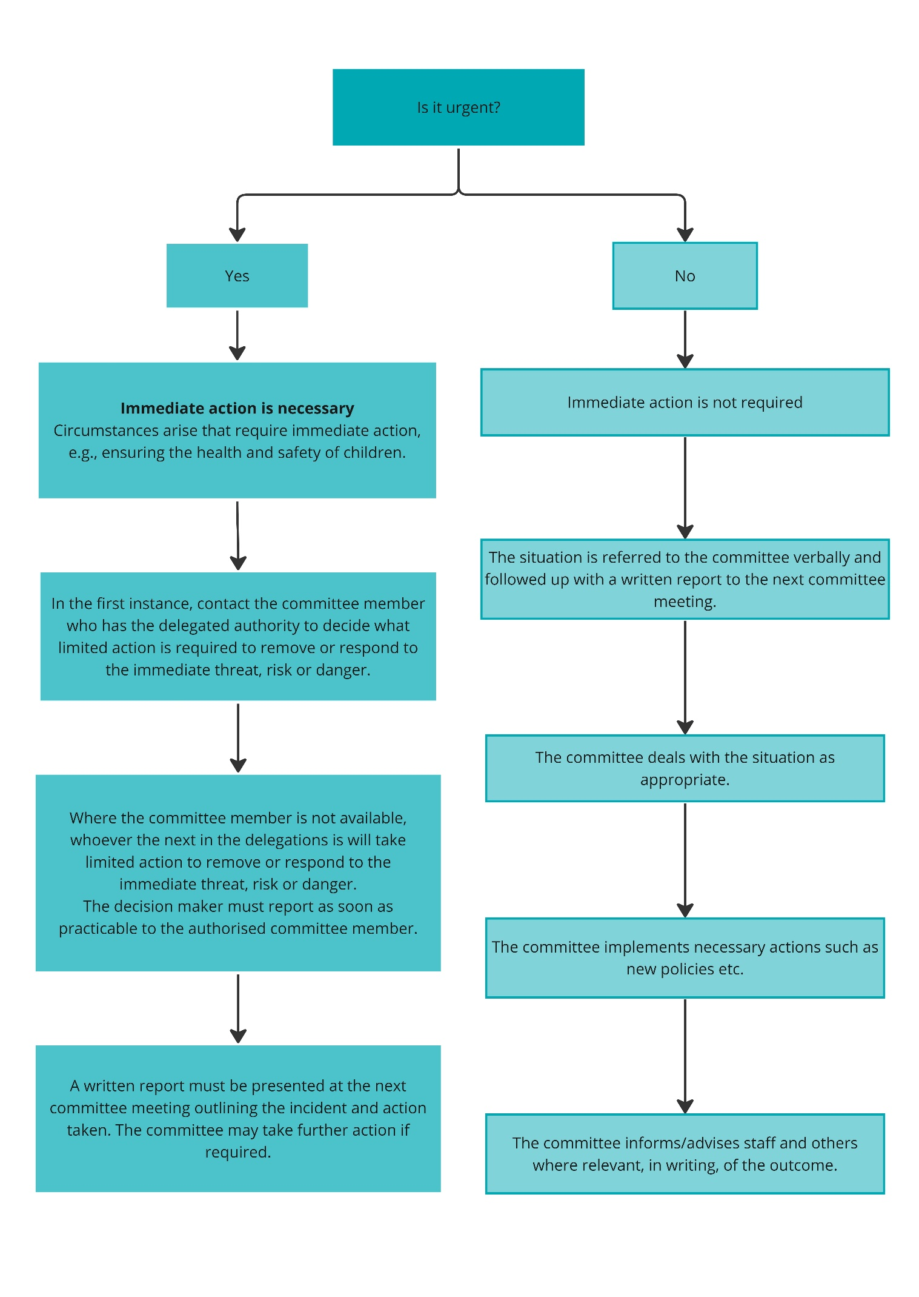

DELEGATION OF AUTHORITY FORM FOR EMERGENCY SITUATIONS

[Insert date]

[Insert name and position of person with delegated authority]

This delegation of authority can only be exercised in situations where immediate action is required and when it is not possible for the matter to be dealt with by the committee; for example, to ensure the health and/or safety of children in accordance with the *Education and Care Services National Law Act 2010* and/or *Education and Care Services National Regulations 2011*.

The purpose of this authority is to authorise temporary and/or limited action, which will remove the immediate hazard, threat or risk until the matter can be dealt with by the committee. Therefore, the committee:

1. authorises decision-making responsibility to be exercised by:

* the president, [Insert name], or in their absence
* the vice-president, [Insert name], or in their absence
* the nominated supervisor, [Insert name], or in their absence
* the person in day-to-day charge [Insert name/s]

1. authorises the expenditure of up to $ [insert amount] to support any action to remove the immediate hazard, threat or risk.

This delegation was authorised by the committee at its meeting held on [insert date of committee meeting].

|  |  |  |  |
| --- | --- | --- | --- |
| **Signature:** |  | **Date:** |  |

[Insert name of committee member who will sign authorisation]

[Insert position of committee member who will sign authorisation]