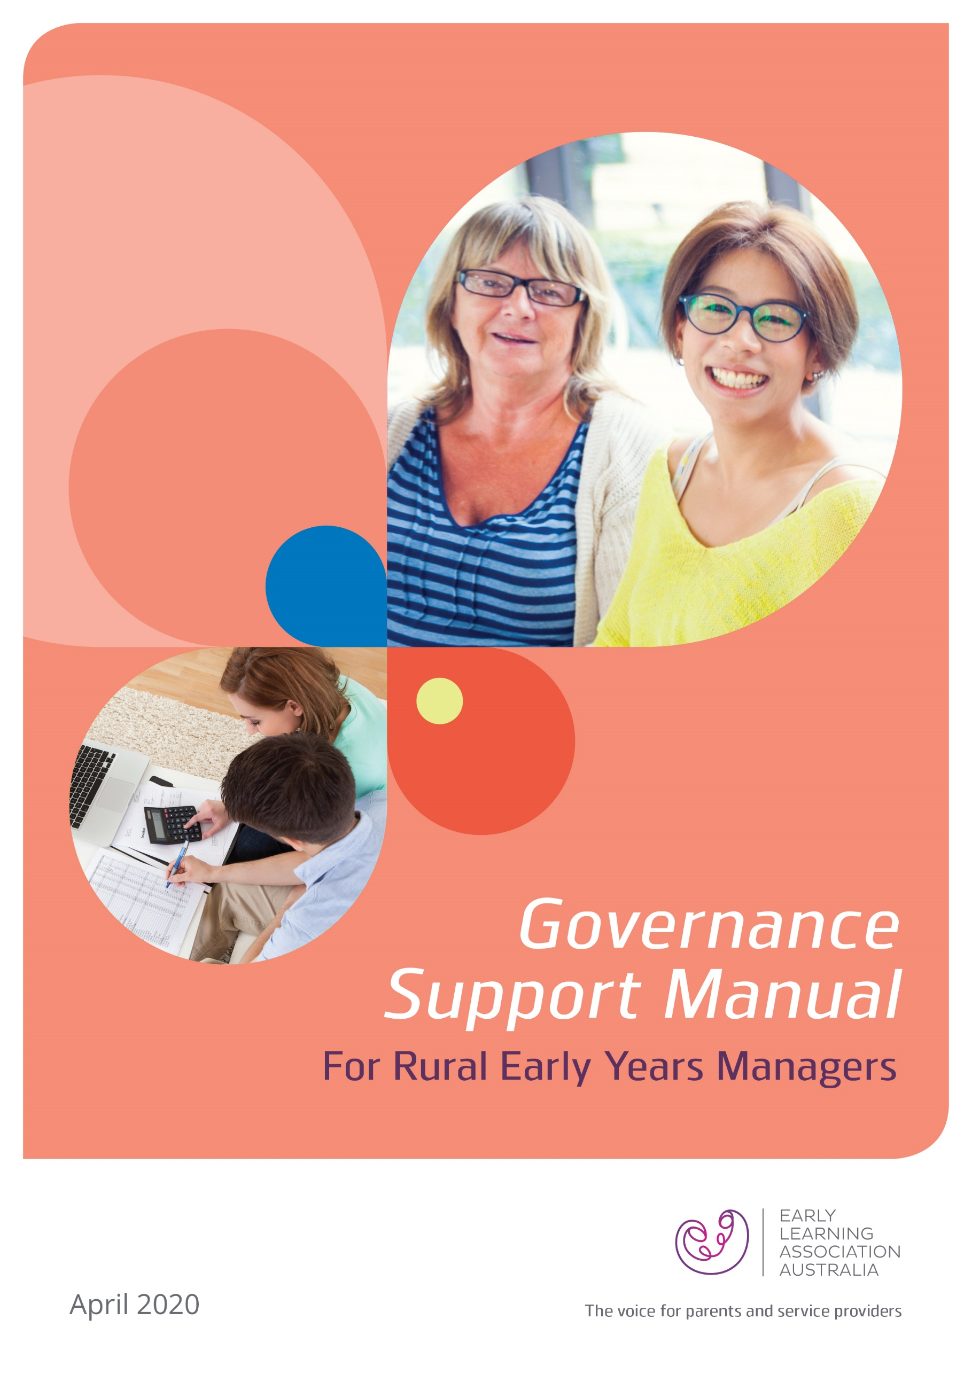

# Table of Contents

Introduction 2

The Rural EYM Governance Project 2

Introduction to this manual 2

Disclaimer 3

Other relevant resources 4

A. People and Roles 5

1.1 Position descriptions 5

a) Ordinary Board Member 5

b) Chairperson/President of the Board 8

c) Board Secretary 10

d) Treasurer 13

1.2 Skills Matrix 15

a) Sample Board Skills and Competency Matrix 16

1.3 Board recruitment and succession planning 18

a) Sample Board recruitment checklist 21

b) Sample Board of Directors Application Form 23

c) Board Induction Manual 24

B. Policies and Procedures 27

1.4 Board Charter 27

1.5 Code of Conduct 29

a) Template Code of Conduct 29

1.6 Other governance policies 32

C. Probity and accountability 33

1.7 Internal controls 33

1.8 Role of the Board 36

1.9 Managing risks 38

1.10 Delegation of authority 42

D. Planning and Stewardship 44

1.11 Strategic Planning 44

a) Strategic Plan Template 49

1.12 Board work plan 52

E. Performance assurance 53

1.13 Board evaluation 53

F. Participation and empowerment 57

1.14 Communication and engagement 57

Mapping stakeholders 57

Developing a communication and engagement strategy 59

The Rural Governance Project is undertaken by Early Learning Association Australia (ELAA) on behalf of the Department of Education and Training (DET).

Published by Early Learning Association Australia

Level 3, 145 Smith Street, Fitzroy, Victoria 3065

© Early Learning Association Australia 2020

# Introduction

## The Rural EYM Governance Project

The Rural EYM Governance project was funded by the Department of Education and Training (DET) in recognition of the unique challenges faced by Early Years Managers (EYMs) operating in rural and regional areas in Victoria, to maintain sustainable governance arrangements.

Early Learning Association Australia (ELAA) undertook this project with the support of ten EYMs. A ‘pulse check’ assessment[1] of the governance systems and practices undertaken as part of this project showed that while the EYMs were doing well in several areas, there were some areas where further support in the form of information and resources were required to help EYMs strengthen their governance practices.

ELAA has developed this Governance Support Manual (manual) addressing some of the practice areas that required further strengthening. The manual provides information, guidance resources, templates and references/useful links that EYMs in rural and regional Victoria can use to further strengthen their governance systems and practices and ensure their ongoing long-term viability.

## Introduction to this manual

This manual is one of three resources developed by ELAA to support rural EYMs with their governance. The other resources are:

1. **Governance Literature** **Review** providing a detailed overview of the literature on governance practices pertinent to EYM organisations and early years services. The information in this document has been sourced from literature published by reputable governance bodies in Australia and overseas, and from the reviews of the Kindergarten Cluster Management (KCM) system in Victoria commissioned by the Government[2].
2. **The Governance Assessment Guide** forthe Board and senior staff of rural-based EYM organisations to assess their governance performance. The Guide sets out 65 governance practices, grouped under seven principles of good governance. This guide formed the basis of the assessment that ELAA undertook during this project. On an ongoing basis, this resource can be used by rural EYMs to self-assess the effectiveness of their governance systems and practices. This resource can also be incorporated into the internal audit system of the larger EYMs who may have an internal audit system in place in their organisation.

The information, tools and templates in this manual have been grouped under the seven principles of good governance and in the three areas below:

* Foundational resources
* Planning for success
* Partnership and collaboration.

Where resources are freely available online from reputable sources, links have been provided to enable EYMs to download the resources to add to this manual.

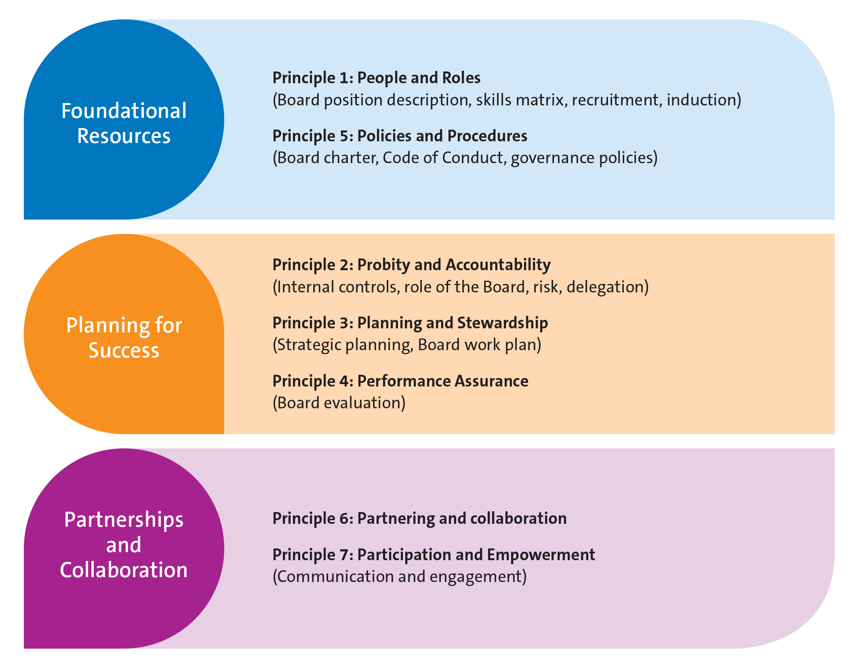

## Disclaimer

ELAA has made every effort to ensure that the weblinks and information provided in this manual are accurate and current at the date of its publication. ELAA expressly disclaims any liability or responsibility for any errors or omissions from this publication. Legislation, regulation and standards change regularly and it is the responsibility of the EYM using this manual, to seek advice about and ensure the currency and application of the information contained in this publication.

The information provided in this manual and the templates contained herein are advisory in nature only and it is the responsibility of the EYM using this manual to ensure they meet the specific needs of their organisation.

This manual is a copyright of the Early Learning Association Australia and is free for use by Early Years Managers in Victoria and the Department of Education and Training (DET). Third parties seeking to use this document or parts of it must not do so without express written permission from ELAA.

## Other relevant resources

This manual is designed to be used in conjunction with other key documents that may impact on EYM organisations, such as:

* The Constitution
* Local government strategic plans
* Municipal Health and Wellbeing Plans and Municipal Early Years Plans
* The National Quality Framework
* Kindergarten Funding Guide
* EYM Policy Framework
* EYM Kindergarten Operating Guidelines

### Australian publications for NFP Boards

The ACNC and Justice Connect have published helpful resources to support not-for-profit organisations with their governance. Links to access these free resources are provided below:

* Australian Charities and Not-for-Profit Commission: Governance for Good – the [ACNC’s guide for charity Board Members](https://www.acnc.gov.au/tools/guides/governance-good-acncs-guide-charity-board-members)
* Justice Connect: Not-for-Profit Law – [Governance and legal duties of office holders](https://www.nfplaw.org.au/governance).

ELAA resources

ELAA has a number of resources that are available to assist early childhood education and care service providers with their governance, service management, human resourcing and more. Some of these resources are available for purchase while others are freely available for download from ELAA’s website:

* ELAA Early Childhood Management Manual ($250 for ELAA members, $950 for non-members)
* ELAA PolicyWorks Manual ($250 for ELAA members, $950 for non-members)
* ELAA Employee Management & Development Resource (freely available).

# A. People and Roles

## 1.1 Position descriptions

The constitutions of most EYM organisations contain a high-level description of the roles of the key office bearer or executive positions, e.g., the Chair person, Treasurer, Secretary etc. This section contains template position descriptions (PD) for Board members holding various positions and outlines the knowledge, skills and attributes commonly required to perform the roles. EYMs can use this template when recruiting new members to their Boards.

#### Important note

The PDs in this section are generic, and EYMs must tailor them to suit their organisation’s needs and circumstances;

EYMs must also refer to their organisation’s constitution to ensure any requirements in that document in relation to these positions are also included.

### a) Ordinary Board Member

The following is a suggested position description for a Board member in general.

Background

[Briefly describe the organisation’s business and the benefits to the prospective Board member of being on the organisation’s Board].

Position summary

The Board of the [EYM Name] is the governing body of the organisation and has statutory responsibilities in accordance with the following:

* Corporations Act 2001 (or) Associations Incorporation Reform Act 2012
* Australian Charities and Not-for-Profits Commission (ACNC) Act 2012
* the constitution of [EYM name] and its by-laws, rules and policies.

In addition, as an approved provider of early childhood education and care services and an employer, the Board also has responsibilities under several other legislation and regulations, principal among them being:

* Education and Care National Law Act 2010 and the Education and Care National Regulations 2011
* Occupational Health and Safety Act 2004
* Fair Work Act 2009 and Regulations
* Child Wellbeing and Safety Act 2005.

The Board also have responsibilities for compliance with relevant state government legislation including:

* Child Safe Standards
* No Jab, No Play.

Responsibilities

The Board is responsible for all matters relating to setting the strategic directions, polices, procedures and operations of the [EYM name]. A Board member is accountable to the Board through the Chair.

Responsibilities of a Board member include the following:

* attend and actively participate in Board and Committee meetings, and the Annual General Meeting
* discharge the role diligently and make decisions in the best interests of [EYM name]
* maintain a good understanding of the business of the organisation, its finances, its internal and external stakeholders, its external and internal context and other matters driving and impacting on its performance
* ensure that [EYM name] is in a sound financial position and is not trading while insolvent
* contribute expertise and skills to support the business of the organisation and inform Board decisions
* hold a position on at least one committee of the Board
* represent the organisation externally as required
* in collaboration with other Board members provide stewardship for the organisation
* role model the organisation’s values
* undertake professional development.

Term of office

A Board member will be appointed/elected initially for a term of [insert number of years as per the constitution].

Time commitment

The time commitment required of an ordinary Board member involves approximately [state estimated hours per week/month] for reviewing Board and Committee papers and reports, attending Board meetings and committee meetings, annual meetings, and undertaking special duties as required from time to time.

Qualifications and skills

*General skills*

* ability to maintain effective working relationships with the Chair, CEO and other Board members
* ability to provide advice / counsel to the Chair and other Board members in their areas of expertise e.g., marketing, fundraising etc.
* ability and willingness to commit the time to discharge the role of ordinary Board member.

*Business related competencies*

* prior experience working in an NFP organisation, or on the Board of an NFP organisation
* knowledge and understanding of governance responsibilities and financial literacy
* good understanding of the business of the organisation, its finances, its internal and external stakeholders, its external and internal context and other matters driving and impacting on its performance
* strong leadership skills
* professional qualifications and experience in the respective areas of expertise.

*Personal attributes*

* the ability to act with due care, skill and diligence
* ability to be strategic, and contribute to effective decision making
* ability to discharge fiduciary and other responsibilities with independence and integrity
* be an effective communicator and collaborator
* demonstrate self-awareness and self-management
* have good business instincts and acumen
* have genuine interest in the organisation and its business.

Remuneration

[EYMs can specify here what their organisation’s remuneration policy for the Board is, and its policy for reimbursement of expenses].

Useful links

For more information and guidance on developing the position description for a Board Member, or to access a free template, please visit the [Australian Institute of Company Directors](https://aicd.companydirectors.com.au/-/media/cd2/resources/director-resources/director-tools/pdf/05446-6-4-duties-directors_pd-ned_a4-web.ashx).

### b) Chairperson/President of the Board

The Chairperson of the Board is usually elected in accordance with the constitution of the organisation and holds office for the term specified in it. Organisations must refer to their constitutions for further information on the process of appointment.

#### Important note

The responsibilities and duties described below for this role are in addition to those described in the general PD for an Ordinary Board member.

Position summary

The Chair is accountable to the Board of Directors for their performance. The Chair is responsible for the overall leadership of the Board, ensuring that the Board discharges its role effectively.

The Chair is the principal contact between the Board and the CEO and represents the Board to internal and external stakeholders in terms of its accountability, and presents the public face of the organisation in conjunction with the CEO.

Principal responsibilities

The Chair works closely with the Secretary and CEO to do the following:

* convene Board meetings as required in the organisation’s constitution; determine the agenda for the meetings, ensure all relevant information and materials are provided to Board members in a timely manner in preparation for the meeting
* ensure that meetings of Board Committees are held and reports are presented to the full board for consideration and decision in a timely manner
* ensure Board meetings are open, constructive and inclusive and all members have an opportunity to present their views and ask questions
* be consultative, and ensure appropriate consultation with other Board members as necessary on matters that impact on the organisation
* ensure that the Board evaluates its own performance regularly and has a succession plan for renewal
* oversee the CEO’s remuneration and evaluation of performance.

Qualifications and skills

The Australian Institute of Company Directors[3] recommends a set of personal attributes, business skills and competencies for organisations to consider in appointing to the role of the Chair, as summarised below. The full text of the article can be accessed at the link provided in the footer section.

*General skills*

* ability to maintain effective working relationships with the CEO and other Board members
* conduct meetings in an unbiased manner, with the ability to reconcile opposing views and differences with tact and diplomacy
* ability and willingness to commit the time over and above that expected of the other Board members to lead and represent the organisation.

*Business related competencies*

* knowledge and understanding of and the ability to facilitate compliance and good governance
* leadership and ability to draw on the expertise of fellow Board members to govern the organisation effectively
* good understanding of the business of the organisation, its finances, its internal and external stakeholders, its external and internal context and other matters driving and impacting on its performance
* experience in motivating, managing and dealing with people including evaluating performance, succession planning and executive remuneration.

*Personal attributes*

* ability to discharge their fiduciary and other responsibilities with independence and integrity
* lead from the top, inspire and motivate other Board members, the CEO and staff to fulfil their roles in the best interest of the organisation
* ability to communicate effectively with a range of internal and external stakeholders of the organisation
* demonstrate self-awareness, self-management and empathy
* demonstrate good business instincts and acumen
* demonstrate genuine interest in the organisation and its business.

Remuneration

[EYMs can specify here what their organisation’s remuneration policy for the Board is, and its policy for reimbursement of expenses].

Useful links

For more information and guidance on developing the position description for a Board Chair, or to access a free template, please visit:

* [Our Community](https://www.communitydirectors.com.au/icda/policybank/) (Institute of Community Directors Australia)
* [Australian Institute of Company Directors](https://aicd.companydirectors.com.au/-/media/cd2/resources/director-resources/director-tools/pdf/05446-3-9-mem-director-gr-position-description-chair_a4-web.ashx).

### c) Board Secretary

The role of Board Secretary is a critical role on a Board, with legal compliance duties specified in the legislation under which an EYM is incorporated (e.g., Corporations Act, Associations Incorporation Act), in addition to other duties to support the functioning of the Board.

The Corporations Act and the Associations Incorporation (Reform) Act do not specify that this role must be held by a member of the Board. Consequently, it is common practice in larger organisations to appoint a staff member to perform this role. In other organisations, the CEO is also known to perform the role of the Secretary.

Where a staff member is appointed to the role of Secretary, that person is accountable to the Board through the Chairperson/President of the Board on all matters relating to their governance and board-related responsibilities.

#### Important note

The position description below can be used to define the staff member’s role as the Board Secretary. Where the position of Secretary is held by a member of the Board, the responsibilities and duties described below for this role are in addition to those described in the general PD for an Ordinary Board member

Position summary

The Secretary is accountable to the Board of Directors for their performance, and is responsible for ensuring compliance with the requirements of the [Corporations Act / Associations Incorporation Reform Act]. The Secretary provides advice to the Chair and Board on governance related matters.

Principal responsibilities

The Secretary works closely with the Board Chair to do the following:

* advise the Chair and the Board on all governance matters
* monitor Board compliance with board policies and procedures
* convene meetings and prepare the agenda in collaboration with the CEO
* ensure that all papers necessary for the business of the meeting are despatched to the Board members within the agreed time frame
* ensure registers required under the legislation are maintained, e.g., register of members
* prepare accurate minutes of Board meetings as a record of the business transacted at the meeting
* fulfil responsibilities related to the Annual General Meeting of the organisation e.g., notice of meeting, nominations for Board positions, conduct of elections etc.
* file documents with various authorities as required by legislation and within the relevant time frames
* maintain custody of the common seal of the organisation
* exercise their role as a member of the Board with due diligence and care.

Person specification

The following are specific requirements for a person to be appointed Secretary:

* the person appointed to the position of Board Secretary must be a natural person above 18 years of age
* the person must not be a disqualified person under the founding legislation e.g., Corporations Act etc.
* the person appointed as Secretary must give their consent in writing to act in that role.

Qualifications and skills

*General skills*

* ability to maintain effective working relationships with the Chair, CEO and other Board members
* ability to provide advice / counsel to the Chair and other Board members on governance related matters and attention to detail
* ability and willingness to commit the time over and above that expected of the other Board members to fulfil compliance related responsibilities.

*Business related competencies*

* knowledge and understanding of governance practices and requirements, and the role of the Secretary in ensuring compliance and good governance
* ability to keep accurate record of meetings
* good understanding of the business of the organisation, its finances, its internal and external stakeholders, its external and internal context and other matters driving and impacting on its performance
* experience in formulating and implementing policies and procedures
* experience in a legal or a compliance role may be an advantage.

*Personal attributes*

* a well organised person capable of being up to date with legal compliance requirements and responsibilities
* ability to discharge their fiduciary and other responsibilities with independence and integrity
* ability to communicate effectively with a range of internal and external stakeholders of the organisation
* demonstrate self-awareness and self-management
* demonstrate good business instincts and acumen
* demonstrate genuine interest in the organisation and its business.

Remuneration

[EYMs can specify here what their organisation’s remuneration policy for the Board is, and its policy for reimbursement of expenses].

Useful links

For more information and guidance on developing the position description for a Board Secretary, or to access a free template, please visit:

* [Our Community](https://www.communitydirectors.com.au/icda/policybank/) (Institute of Community Directors Australia)
* [Australian Institute of Company Directors](https://aicd.companydirectors.com.au/-/media/cd2/resources/director-resources/director-tools/pdf/05446-6-7-duties-directors_role-company-secretary_a4_web.ashx).

### d) Treasurer

The Treasurer of the Board is usually elected in accordance with the constitution of the organisation and holds office for the term specified in it. Organisations must refer to their constitutions for further information on the process of appointment.

Position summary

The role of the Treasurer is to work in close collaboration with the other members of the Board and the CEO to:

* ensure that financial management and reporting systems are in place, and
* to safeguard the finances of the organisation.

#### Important note

The responsibilities and duties described below for this role are in addition to those described in the general PD for an Ordinary Board member

Principal responsibilities

The Treasurer works closely with the Board Chair and CEO to ensure the following:

* general financial oversight and ensuring the organisation is solvent
* a sound financial system based on Australian Accounting Standards is maintained for the organisation
* accurate financial records, including income, expenditure, cash flows, accounts receivable and payable and assets and liabilities are maintained
* financial statements are presented to the Board and highlighting matters requiring particular consideration by other Board members
* the development of the financial budget and planning
* compliance with the organisation’s financial delegation policy
* banking systems and processes are in place to support the business of the organisation
* audit and other financial compliance requirements are met
* fixed assets and investments are managed
* they are a bank signatory
* financial reports are presented to members and stakeholders annually.

Qualifications and skills

*General skills*

* ability to maintain effective working relationships with the Chair, CEO and other Board members
* ability to provide advice / counsel to the Chair and other Board members on finance related matters
* ability and willingness to commit the time for oversight of financial matters of the organisation.

*Business related competencies*

* demonstrated financial management experience; knowledge and understanding of Australian Accounting Standards, external audit processes etc.
* ability to ensure compliance and good financial management
* demonstrate good understanding of the business of the organisation, its finances, its internal and internal stakeholders, its external and internal context and other matters driving and impacting on its performance
* have experience in working with an online accounting system/package
* professional qualifications in accounting and/or financial management may be an advantage.

*Personal attributes*

* well organised person capable of being up to date with finances and related responsibilities and attention to detail
* ability to discharge their fiduciary and other responsibilities with independence and integrity
* ability to communicate effectively with internal staff responsible for finances within the organisation
* demonstrate self-awareness and self-management
* demonstrate good business instincts and acumen
* demonstrate genuine interest in the organisation and its business.

Remuneration

[EYMs can specify here what their organisation’s remuneration policy for the Board is, and its policy for reimbursement of expenses].

Useful links

For more information and guidance on developing the position description for a Board Treasurer, or to access a free template, please visit [Our Community](https://www.ourcommunity.com.au/management/view_help_sheet.do?articleid=70) (Institute of Community Directors Australia).

## 1.2 Skills Matrix

A skills matrix identifies the current skills, knowledge, experience and capabilities of the Board and any gaps in skills or competencies that can be addressed in future Director appointments[4]. It also allows the Board to understand the skills mix represented on the Board, and utilise Directors’ skills effectively for the benefit of the business. Public listed companies in Australia are required under the ASX Corporate Governance Principles to disclose the company’s Board Skills Matrix showing the mix of skills and diversity that the Board currently has or is seeking to achieve.

While it is not a requirement for not-for-profit Boards to disclose their skills matrix, ELAA strongly recommends that EYMs have a robust and transparent process to assess their Board composition and ensure that the skills necessary to support the service and good governance are available on their Board. In rural areas where it may be difficult to recruit to Board positions, a skills matrix can be useful to focus an EYM’s recruitment efforts in a targeted manner and to implement strategies described in section 1.3 *Board Recruitment and Succession Planning*, to create a talent pool from which to recruit future members. Reviewing the matrix periodically will ensure that it stays relevant to the current needs and changing environment in which the EYM operates.

The most commonly used method to undertake a skills analysis is self-assessment by the Board using a questionnaire. Regardless of the approach taken by an EYM organisation, care must be taken to ensure that the criteria applied to assess the skills on the Board are agreed by the Board collectively. The criteria can be broadly classified as the competencies required to fulfil the role of Board member and personal qualities that make for an effective Board member. Common criteria suggested by the ASX include the following:

* Executive and non-executive experience
* Industry and sector experience or knowledge
* Leadership skills
* Strategy development
* Behavioural competencies
* Local area knowledge and experience
* Subject matter expertise, e.g., early childhood, education, finance, marketing, communications, fundraising, policy and government relations, risk management, legal, IR, HR, community development etc.

An example of a Board skills matrix is provided below.

Useful links

For more information and guidance on developing a Board Skills Matrix, or to access a free template, please visit:

* Effective Governance: [Board Skills: Building the right board](https://www.effectivegovernance.com.au/board-skills-building-the-right-board/)
* Australian Institute of Company Directors: [Preparing board skills matrix](https://aicd.companydirectors.com.au/-/media/cd2/resources/director-resources/director-tools/pdf/05446-9-mem-director-tools-bc-preparing_board_skills_matrix_web.ashx)
* Australian Securities Exchange: [Creating and disclosing a board skills matrix](https://www.asx.com.au/documents/asx-compliance/creating-disclosing-board-skills-matrix.pdf).

### a) Sample Board Skills and Competency Matrix[5]

|  |  |  |  |  |  |
| --- | --- | --- | --- | --- | --- |
| COMPETENCIES | DIRECTORS | | | | |
| **A** | **B** | **C** | **D** | **E** |
| Industry Knowledge / Experience |  |  |  |  |  |
| Industry experience in the early childhood sector |  |  |  |  |  |
| Knowledge of Early Childhood Sector in Victoria and nationally |  |  |  |  |  |
| Knowledge of broad government policy directions in the early years |  |  |  |  |  |
| Understanding of legislation and regulations in the early childhood sector |  |  |  |  |  |
| Technical skills and expertise |  |  |  |  |  |
| Accounting |  |  |  |  |  |
| Finance |  |  |  |  |  |
| Law |  |  |  |  |  |
| Marketing |  |  |  |  |  |
| Information technology |  |  |  |  |  |
| Public relations |  |  |  |  |  |
| Risk management systems (development and implementation) |  |  |  |  |  |
| Human resource management |  |  |  |  |  |
| CEO / Senior management experience |  |  |  |  |  |
| Strategy development and implementation |  |  |  |  |  |
| Governance Competencies |  |  |  |  |  |
| Board Director experience |  |  |  |  |  |
| Financial literacy |  |  |  |  |  |
| Strategic planning |  |  |  |  |  |
| Compliance |  |  |  |  |  |
| Profile / reputation |  |  |  |  |  |
| Behavioural competencies |  |  |  |  |  |
| Team player / collaborative |  |  |  |  |  |
| Ability and willingness to challenge and probe |  |  |  |  |  |
| Common sense and judgement |  |  |  |  |  |
| Integrity and ethical standards |  |  |  |  |  |
| Interpersonal relations |  |  |  |  |  |
| Listening skills |  |  |  |  |  |
| Verbal communication skills |  |  |  |  |  |
| Understanding of effective decision-making processes |  |  |  |  |  |
| Willingness to devote time to the role |  |  |  |  |  |
| Ability to devote time to the role |  |  |  |  |  |

## 1.3 Board recruitment and succession planning

Having the right mix of competencies and skills on the Board is essential to meet the needs of a rural EYM organisation. Finding people with a balance of skills to recruit to the Board can be particularly challenging for EYMs operating in rural and regional areas. Developing a sound recruitment and succession planning process helps EYMs anticipate the skills needed on the Board in advance of a vacancy becoming available, and target their recruitment effort effectively.

As the Board skills and competency matrix (Kiel et al) in the previous section recommends, to the extent possible, every Board should have an appropriate mix of skills in each of the categories – industry, technical, governance and behavioural. The appropriate mix is determined by a range of factors, principal among them being the strategic plan of the EYM, major projects that have been planned requiring specialist expertise, changes in government policy, legislation and regulatory changes etc.

Important considerations

The following factors are important when considering Board membership:

* a Board member role is generally voluntary in most EYMs. It is nevertheless a crucial leadership role. The EYM’s process must therefore focus on finding the right person who can be entrusted with making critical decisions for the organisation, and not be driven by the need to make up the numbers required by the constitution.
* recruitment efforts are not a one-time exercise. Some EYM constitutions may limit the term of office for Board members, or Board members may resign during their tenure, resulting in a turnover of members on a regular basis. An EYM’s recruitment process should incorporate strategies to have access to a ready pool of potential Board members such as, maintaining an ongoing ‘interest/lead/application pool’ to recruit from as and when a vacancy becomes available.
* other than time-limited positions, being on an EYM Board is a long-term relationship between the organisation and the member. A structured recruitment process is essential not only to ensure a consistent process but to also get to know the potential member and lay the foundations for this long-term relationship.
* from time to time, an EYM Board may require a person with specific expertise on the Board to support them for a limited time, e.g., a short-term project. If the Constitution of the EYM permits, such needs can be filled by co-opting a member with the required expertise to the Board on a short-term basis, to focus on the specific task or project.

In rural areas where recruitment can be difficult, if people are unable to make a longer-term commitment required for a full-term position, co-opted positions offering a shorter time commitment can be less challenging to fill.

Specific skills required in the short term can also be utilised through the experts being included on committees of the Board. It is not uncommon for the person who holds such short-term or committee positions to transition into a full Board member role, because their engagement through the short-term role provides them with a better understanding of the business and the contribution they can make.

Board recruitment and selection

This section provides an overview of the critical steps that an EYM Board should consider when recruiting to the Board.

Step one: Define the need

The first step in the process is to define the skills that the EYM requires on the Board to assist in achieving its strategic goals. This can be done by using (or adapting) the sample Board skills matrix_Sample_Board) to ascertain the skills that currently exist, and identifying any gap in required skills. Once identified, a position description for the role can be developed to target the recruitment effort to attract a Board member with the necessary skills and expertise.

Step two: Delegate responsibility for recruitment

Depending on the EYM’s size, needs and other local considerations, the method adopted for recruiting new Board members can vary from one organisation to the other. It is common in smaller organisations for existing Board or Committee members to refer to the recruiting group, individuals whom they consider suitable. The executive of the Board[6] may in these instances undertake the recruitment activities following established policy and processes. Larger organisations may choose to delegate this responsibility to a committee.

Whatever method an EYM implements, it is important to have a structured process for recruitment, and the person appointed to lead the process is committed in following that process.

Step three: Find potential candidates

If the EYM has a system in place to document potential leads or record interest from volunteers on an ongoing basis, the process for screening potential candidates could commence there.

The following are other recruitment options that EYMs may consider:

* referrals and word-of-mouth from friends/colleagues/associates of existing, retiring or past Board members, sub- committee members, staff or volunteers
* publicising within existing networks such as professional and trade associations that your organisation/staff/Board members are affiliated to; Donors; Volunteers etc.
* through the networks or members of Parent Advisory Groups (PAGs)
* external promotion through community newspapers, local volunteer organisations, schools etc.
* internal promotion through notices in parent newsletters, information sessions, existing advisory groups etc.
* from existing Board committees and advisory groups
* advertise online through organisations specialising in not-for-profit recruitment, e.g., Ethical Jobs, Our Community etc., or by approaching specialist recruiters
* promoting through social media channels.

The template position descriptions can be adapted to support the recruitment effort.

Step four: The selection process

The selection process commences with the collection of biographical information from prospective Board members through an application form. In addition to information about the individual’s qualifications and experience, this form can also seek information that outlines:

* their interest and motivation in joining the EYM’s Board
* what they will bring to the Board
* what they hope to get out of it
* any other Boards they are members of
* any potential conflict of interest etc.

The screening process follows next to determine suitability for the position. This involves:

* matching the skills of individual applicants to the assessed need (using the skills matrix) and shortlisting the applicants who most closely match the required profile
* a face-to-face meeting/interview with the shortlisted candidates to make the final selection.

Having a defined set of criteria to guide the short-listing and interview process is important to ensure that all candidates are assessed consistently in terms of their skills and fit for the Board, and their values, personality and attitude.

The final step is to select the candidate who closely matches the skills/profile that the Board is seeking to recruit and notify them. The notification to both successful and unsuccessful candidates should preferably be through a personal call from the person chairing the recruitment committee, or the Chair of the Board.

It is important to check the organisation’s constitution at this stage to ascertain the process of formally appointing the person to the Board. Some EYMs may have provisions in their constitution that allow the Board to pass a resolution approving the appointment of a member, others might require an election at the Annual General Meeting (AGM) of members. Depending on the process prescribed in the constitution, the appointment is finalised through a formal letter from the Chair of the Board.

If there are more candidates shortlisted than available vacancies, the EYM can harness this interest to create a pool of potential candidates for future appointment. The EYM Board may also:

* ascertain whether the candidates are interested in being contacted when a future vacancy arises, and retain their detail on file
* offer a position on a committee if there are such positions available and their skills are suitable, with an option to progress to the Board when a vacancy arises. Committees make good holding pools for prospective Board members, enabling existing members to see them in action and giving them a chance to understand the organisation and how it works
* consider opportunities for them to engage with the organisation as a volunteer, if the person is interested in undertaking other volunteer work.

### a) Sample Board recruitment checklist

The checklist below is provided as a guide to help EYMs with the various tasks involved in a recruitment process

|  |  |  |
| --- | --- | --- |
|  | Task | Status |
| 1. | Complete the skills matrix |  |
| 2. | Identify the skills gap and confirm with Board members |  |
| 3. | Prepare / modify position description with key responsibilities and expectations |  |
| 4. | Board resolution to set up recruitment committee (or delegate responsibility to an existing one) |  |
| 5. | Application form developed or modified for recruitment |  |
| 6. | Search through list of leads/interested candidates if any |  |
| 7. | If no list or no suitable candidate is available, advertise the position (refer to suggestions above) |  |
| 8. | Applications received by closing date |  |
| 9. | Short-listing process  - review application (recruitment committee members individually)  - meet to discuss and finalise shortlisted candidates |  |
| 10. | Interview dates set and invites sent – chair of recruitment committee |  |
| 11. | Interview questions/criteria prepared |  |
| 12. | Interviews conducted |  |
| 13. | Committee meeting to finalise selection |  |
| 14. | Check constitution for Board member appointment process |  |
| 15. | Phone call to convey outcome of selection process to successful candidate(s) – Chair of Board or Chair of selection committee |  |
| 16. | Phone call to convey outcome of selection process to unsuccessful candidate(s) – Chair of Board or Chair of recruitment committee |  |
| 17. | Formal appointment process completed (e.g. Board resolution, AGM election etc.) |  |
| 18. | Formal letter of engagement sent to new Board member |  |
| 19. | Shortlisted candidates who were unsuccessful contacted regarding other options to engage with the organisation. |  |
| 20. | Report of the recruitment committee presented to the full Board |  |

### b) Sample Board of Directors Application Form

#### Important note

This form must be tailored by EYMs to suit their specific needs. The document should be printed on the EYM’s letterhead.

|  |  |
| --- | --- |
| Name |  |
| Address |  |
| Contact phone number |  |
| Email address |  |
| Current employment details  - Organisation  - Type of business  - Role  - No. of years in the role |  |

**a)** Please list Boards and Committees that you are currently serving on, or have served on in the past. Please list name of organisation, role, and years on the Board/Committee.

**b)** Skills, Experience, Interests (check all that apply)

Suggested list of skills to include:

(*Fundraising, Marketing, Communication, Public Relations, Events management, Administration and Management of Early Childhood Service, Grant writing, Advocacy, Government Relations, Information Technology, Governance, Not-for-profit experience, Policy development, Education, Human Resources, Community/Welfare services, Other*).

**c)** Why are you interested in joining the [EYM name] Board? What do you hope to gain from this experience?

**d)** How do you feel [EYM name] can benefit from your involvement on the Board?

**e)** If successful, are you able to commit the time indicated in the position description to fulfil your responsibilities?

**f)** If you are not successful, would you like to volunteer or assist our organisation in other ways that match your skills and interest?

Please attach a copy of your current resume and send it to the following email address by [specify date] [provide email address to send application to].

All Board appointments are subject to satisfactory completion of police check, and Working with Children Check (volunteer).

By completing this application, you are verifying that all the information you have provided is true.

### c) Board Induction Manual

Introduction

A board manual or handbook is an important resource for EYM Board members and contains all necessary information that a member needs to know about the organisation, to discharge their responsibilities effectively. It is also an effective induction tool for new Board members, and a reference tool throughout their term in office.

The contents of a Board manual may be different for each EYM, depending on the size of the organisation, the Board structure and needs. However, it is common for a Board manual to contain most of the information and documents listed below. It is important to ensure that the Board manual contains current and up-to-date information. A Board member, or a Board committee or the CEO may be delegated the responsibility for updating the manual regularly or as each new Board member commences.

Suggested contents for the Manual

Category 1: Introducing the organisation

* A brief history of the organisation
* Vision, Mission and value statements and the service philosophy
* A brief summary of service operations:
  + types of early years programs delivered
  + number of services managed by the EYM
  + funding received and funding sources
  + membership information, etc.
* Key partnerships, stakeholders and alliances
* Major projects if any
* Contact information for the EYM organisation – its address, telephone and fax numbers, email and website address, social media etc.

Category 2: Legal/Regulatory/Government Policy

* Constitution
* Licences/permits held by the organisation and other related information
* Insurance held by the EYM (for Board members and for the EYM organisation)
* Relevant policy documents such as the EYM Policy Framework, EYM Kindergarten Operating Guidelines, Kindergarten Funding Guide, Early Childhood Reform Plan, funded three-year-old kindergarten, etc.
* A brief summary of the regulatory environment for early years’ services, e.g., ACECQA, NQS etc.

Category 3: Sector/contextual information

* AEDC data for the areas where the services are located
* Population projections and trends, e.g. Victoria in Future data
* Enrolment data for the service and enrolment trends
* Municipal early years plans, etc.
* DET Kindergarten parent opinion survey results
* Early childhood community profiles
* Victorian Child and Adolescent Monitoring System (VCAMS) data
* Any other relevant sector level reports
* Acronyms used in the sector.

Category 4: Board-related information and documents

* Board structure, and roles
* Board Charter
* Board policies and procedures including delegations
* Board Code of Conduct
* Minutes of at least 3 recent board meetings (updated once a year)
* Board resolutions (at least for one year)
* A Board meeting schedule and a calendar of upcoming events
* Any board reviews, reports or evaluations that have been undertaken
* A list of the board's current committees, including terms of reference and details of chairs and members
* Any committee reports to the Board during the previous year
* Relevant templates (e.g. board agenda) – include as attachments
* Brief information about current board members (names, contact details and a short biography) and the CEO.

Category 5: Operations-related information and documents

* Strategic Plan
* Operational/business plans to operationalise the strategic plan
* Summary of any recent submissions, grant applications etc.
* Fundraising and marketing plans if any
* Quality rating and quality improvement plans
* Service improvement plans
* Most recent report on progress against strategic plan
* CEO report to three prior board meetings
* Current year's budget
* Financial statements for the year, including cash flow reports, variance analysis etc.
* Most recent annual report and auditor's report
* Organisational chart
* Staff names, titles and areas of responsibilities (including volunteers, if relevant)
* Staff/HR policies and procedures
* Organisational policies and procedures
* Organisational marketing brochures, media articles etc.
* Recent parent survey reports if any
* Recent staff survey reports if any.

# B. Policies and Procedures

## 1.4 Board Charter

A Board Charter is a written policy document that clearly sets out the respective roles, responsibilities and authorities of the Board, both individually and collectively, and management in setting the direction, the management and the control of the organisation[7].

Purpose

This is an important foundational document that assists good governance. The EYM Board plays an active and lead role in developing its own charter. If developed carefully, and used and reviewed regularly, this document can become a standard ‘go to’ tool to get an understanding of the legal framework within which the EYM Board operates, the roles and responsibilities of the Board, and the operating procedures and policies of the Board.

Developing a Board Charter

A Board Charter development process follows five key stages[8]:

* Collecting information
* Analysing information
* Drafting the Charter
* Board approval process
* Annual review.

Contents of a Board Charter

There is no prescription about the contents of a Board Charter, and it is up to a Board to collectively decide what to include in the document. As a general guide, some organisations choose to base their charters on the ASX Corporate Governance Council Principles[9] which include the following:

* Roles and responsibilities of the Board, office bearers on the Board, Company Secretary and the CEO
* Process for appointing/electing a Director
* Board policies
* Board Committees
* Mix of skills on the Board
* Composition and independence of the Board
* Induction and professional development for Directors
* Board Code of Conduct
* Board meetings
* Process for evaluating Board performance and the performance of the CEO
* Process for managing conflict of interest
* Review of the Charter.

The Corporate Governance Practice Framework developed by Effective Governance[10] has also been adopted by many organisations as the basis of developing their Board Charters. This is a more detailed model that defines various governance roles, key Board functions in relation to strategy, compliance, monitoring, managing risks, decision making, communication etc., key Board processes such as meetings, minutes, committees etc., and measuring Board effectiveness.

Useful links[11]

The following are the website links to the materials referred in this section, and may provide a useful guide to EYMs who wish to develop their own charter, or review and update an existing charter:

* Australian Institute of Company Directors: [Board Charter Role of the Board](https://aicd.companydirectors.com.au/~/media/cd2/resources/director-resources/director-tools/pdf/05446-5-3-mem-director-rob-board-charter_a4-web.ashx)
* Australian Securities Exchange: [Corporate Governance Principles and Recommendations](https://www.asx.com.au/documents/asx-compliance/cgc-principles-and-recommendations-fourth-edn.pdf)
* Effective Governance: [Board Charter Fact Sheet](http://www.effectivegovernance.com.au/wp-content/uploads/2016/08/eG-Board-Charter-Fact-Sheet_v0.3_18Aug16.pdf).

## 1.5 Code of Conduct

A Board Code of Conduct defines the standard of behaviour expected of the Board individually and collectively in the governance of the organisation. For an EYM organisation, it is important to ensure that the code also aligns with the organisation’s values and service philosophy. The Board Code of Conduct is sometimes the same as an organisational Code of Conduct.

A template Code of Conduct is provided below to assist EYM organisations and can be adapted to meet their organisation’s needs.

### a) Template Code of Conduct

**Code of Conduct for [EYM name] Board**

The members of the Board of [EYM name] are bound by this Code of Conduct. All Board members shall follow the standards of behaviour set out in this code, in the fulfilment of their roles and responsibilities as members of the [EYM name] Board. Board members must familiarise themselves with this Code of Conduct and the [EYM name] values and clarify any concerns with the Chair of the Board.

As Board members of the [EYM name] Board, we will:

**a)** **act with honesty and integrity**

* be open and transparent in all our internal and external dealings in discharging our roles as Board members of [EYM name]
* use our authority as Board members in a responsible manner
* avoid or disclose any conflicts of interest and abide by the conflict of interest policy of [EYM name]
* act in a manner that sustains public trust in [EYM name].

**b) act in good faith in the best interests of [EYM Name]**

* be accountable for our actions and take responsibility for our decisions
* act in the best interests of [EYM name] and the children and families who access our service at all times, and not bring the organisation into disrepute as a result of our actions
* work cooperatively with other Board members on the [EYM name] Board to discharge our responsibilities.

**c) act fairly and impartially**

* avoid bias, discrimination or self-interest while making decisions
* be inclusive and demonstrate respect for others, and act professionally and courteously in the discharge of our duties as Board members.

**d) exercise due care and diligence**

* consider all relevant facts before making a decision
* seek information or clarification as necessary to ascertain facts and other implications before making a decision.

**e) use information appropriately**

* respect confidentiality and use information for the purpose for which it was made available
* not use information we receive as a member of the Board to gain personal advantage
* ensure all personal, commercial and other information provided to us as Board Members are handled in accordance with the privacy policy and privacy obligations of [EYM name].

**f) use position as Board member appropriately**

* avoid using our position as a Board Member to gain an advantage for ourselves, our family members, or associates or cause detriment to the interests of [EYM name].

**g) act in a financially responsible manner**

* read and understand or seek help to understand financial reports and all financial material that is presented to the Board
* make financial decisions in a responsible manner after seeking and understanding all relevant information necessary for the decision.

**h) comply with the law, regulations and governance rules**

* **have a good working knowledge of all laws and regulations that apply to [EYM name]**
* **have a good working knowledge of [EYM name]’s constitution, and other governing documents, policies and procedures relating to our roles as Board Members**
* **act within the powers set out by the constitution of [EYM name].**

**i) demonstrate leadership and stewardship**

* **act in accordance with the values of [EYM name]**
* **role model appropriate behaviour in accordance with this Code of Conduct and actively shape the culture of [EYM name] from the top**
* **encourage a culture of accountability, and child safety, manage risks effectively and responsibly to keep [EYM name] strong and sustainable.**

Values

The values that underpin this Code of Conduct are:

[List your organisation’s values here].

Breaches of this Code of Conduct

Any breach of this Code of Conduct should be reported to [Chairperson/Governance Committee].

Review date

This code was approved by the Board of [EYM name] on [enter date] and will be reviewed on or before [insert review date and year].

Authorisation

<Signature of Board Secretary>

<Date of approval by the Board>

<Name of organisation>

## 1.6 Other governance policies

Governance policies are a set of principles and rules that define the manner in which a Board will function to ensure the organisation’s purpose is fulfilled, and it is effectively and ethically managed. These are different from operational policies in that they are specific to the Board, the roles and responsibilities of its members and their interactions with each other. Most EYMs may already have a few governance policies that are required under Quality Area 7 – Governance and Leadership of the National Quality Framework.

The Policy Bank developed for not-for-profit organisations by Our Community[12] offers free templates for the following governance policies that EYMs may wish to utilise to develop a complete set of governance policies for their organisations.

* Governance
* Attendance at meetings
* Confidentiality
* Conflict of interest
* Dispute resolution
* Fundraising
* Grievance
* Induction
* Recruitment
* Office bearer policy and position statements
* Budget planning
* CEO recruitment
* Committees
* Conduct of meetings
* Delegations
* Risk Management.

ELAA strongly recommends EYMs to utilise this resource, which is free for not-for-profit organisations, to tailor governance policies to suit their specific needs and circumstances.

# C. Probity and accountability

## 1.7 Internal controls

Internal controls are essential to provide members of an EYM Board with a reasonable level of assurance that the operations are going according to plan and the reporting and compliance obligations of the EYM are being met. A good internal control system ensures that the likelihood of errors and mismanagement are minimised and issues that might have a significant impact on the organisation are detected early and addressed.

As the governing body of the organisation, the Board’s responsibility for internal control primarily involves oversight, authorisation and ethical leadership. The Board relies upon management to create the policies needed to ensure services are provided effectively, the organisation’s finances are managed well and its assets are safeguarded. The CEO or Manager of the EYM provides the leadership necessary to establish and implement the internal control framework that provides this assurance to the Board.

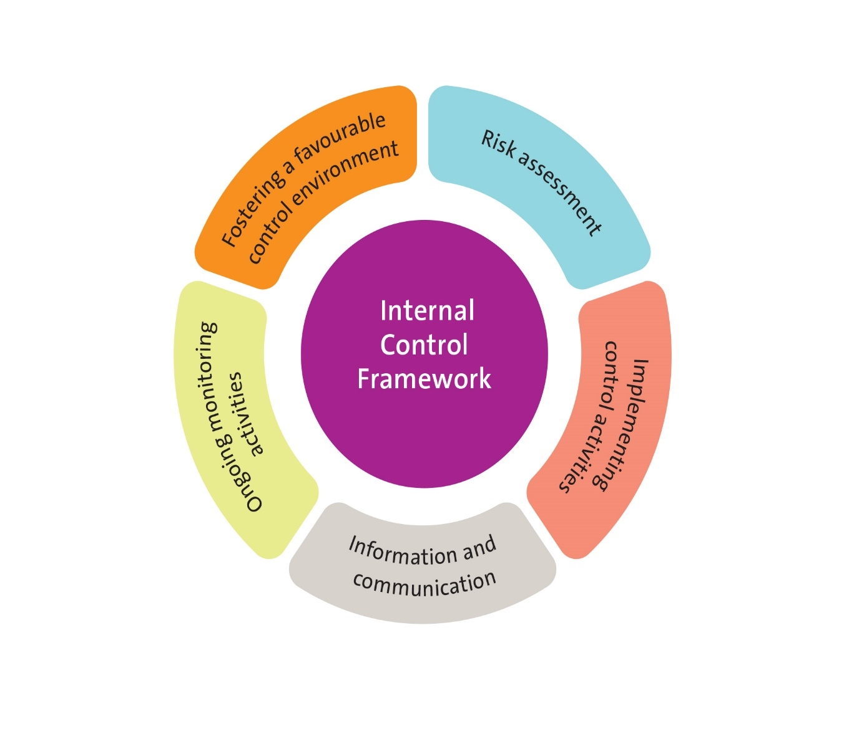The COSO model[13] for evaluating internal controls sets out five inter-related elements for an internal control framework, and the success of the internal control system depends on how well these elements function and are coordinated and integrated with each other. This framework is widely acknowledged as the governance industry standard against which organisations measure the effectiveness of their internal control systems.

a The control environment

The control environment comprises standards, processes and structures that provide the basis for carrying out internal control across the organisation[14]. It is the responsibility of the EYM Board and senior management to lead from the top and create a favourable environment within the organisation to implement the internal control framework. This includes a commitment from the top to integrity and ethical values, independence from management, proper oversight of the development and implementation of internal control processes, appropriate organisation structure and reporting lines and processes, delegation of authority and responsibility with checks and balances to hold people accountable, and a commitment to recruit and retain staff aligned with the goals and values of the organisation.

b) Risk assessment

The next element is an assessment of internal and external risks that have the potential to adversely impact on the achievement of the organisation’s goals. The EYM Board must work with management to clearly define the goals to be achieved, and its risk appetite, providing management with a sound basis on which to identify and assess risks and develop a strategy to manage them.

c) Control activities

Control activities are the actions that the EYM establishes through its policies and procedures with a view to achieving the organisation’s goals, and managing risks. Typical control activities involve a range of checks and balances such as approvals, authorisations, delegation limits, reviews, verifications, role split etc.

d) Information and communication

Information and communication are an essential element of a successful internal control system, and works both ways. Internally, it provides management with the information and data necessary to support the other elements of internal control. It also enables staff to understand and respect the control system in the organisation and their roles and responsibility in relation to it. Externally, it provides stakeholders assurance about the effective management of the organisation.

e) Monitoring

Monitoring activities in an internal control system can take the form of:

* ongoing oversight by the Board through the reports, briefings and other materials presented to Board meetings by management; through the risk and audit committee; scheduled review of policies and procedures etc.
* periodic review/evaluations through internal audits; meetings with the CEO to review compliance with legislative and regulatory requirements etc.
* annual external audit, and meetings with regulators/funders to understand gaps/deficiencies/opportunities for improvements in operations and service delivery.

As mentioned earlier, the presence of an internal control system does not provide the Board and external stakeholders an absolute assurance about its internal operations, risk management and compliance. The limitations arise from human failure, errors in judgement, ability and opportunity for employees within the organisation to override or circumvent controls, external events that are unforeseen and beyond the Board and management’s control etc. The Board and management’s awareness of and vigilance in monitoring the implementation of internal controls can help minimise the limitations to some extent.

## 1.8 Role of the Board

The EYM Board is primarily responsible for the governance of the organisation, setting strategic directions, and is accountable to its members for the organisation’s performance. Depending on the size of the organisation, availability of skills, and other factors that are unique to rural areas, rural EYM Boards may also have to take an operational focus in addition to their strategic focus.

The diagram below represents the key role of the Board broken down into six dimensions covering various aspects of the organisation’s functions.

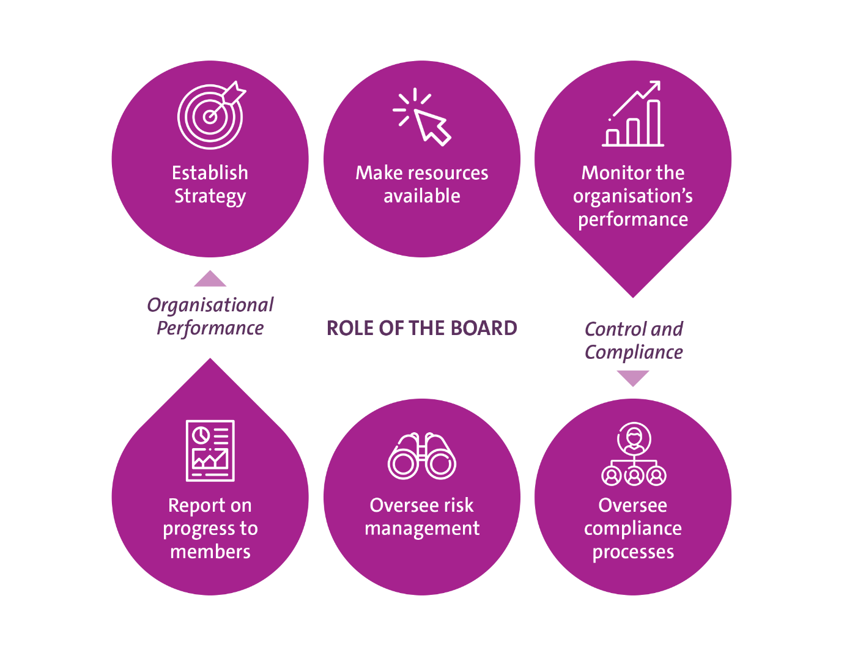

Adapted from AICD, Principle 2: Roles and Responsibilities.

Specific responsibilities of the Board in relation to **organisational performance** include:

* Providing strategic direction, and setting objectives and goals
* Approving budgets, capital expenses and business plans to implement the strategy
* Monitoring organisational performance against strategy
* Monitoring the financial position of the organisation
* Tasks related to the CEO of the organisation such as appointing/removing, remunerating, evaluating, managing performance etc.
* Supporting management in their performance and achievement of goals
* Leading by example and setting a positive organisational culture that encourages transparency and accountability.

Specific responsibilities in relation to **compliance and control** include:

* Developing a Code of Conduct and ensuring policies and procedures to support their implementation are developed and implemented by management
* Ensuring appropriate internal controls and compliance systems are established
* Ensuring policies and procedures are reviewed regularly to keep them relevant
* Ensuring reporting structures are established to receive financial and other reports from management and satisfying itself that all legislative and regulatory compliance obligations are fulfilled
* Setting the organisation’s risk appetite and overseeing the management and reporting of risks by management
* Ensuring members and stakeholders are presented with financial and annual progress reports in line with the constitution and best practice
* Receiving reports from annual external audits and acting on improvements if any that may be required
* Ensuring the Board has the necessary skills to perform their role, has a workplan, a succession plan, and takes measures to evaluate its own performance
* Engaging with members and stakeholders and ensuring relevant information and reports are disseminated as necessary.

## 1.9 Managing risks

A critical component of the strategic leadership role of the Board is the oversight of risk and ensuring it is managed appropriately. The International Organisation for Standardisation (ISO) defines risk as the effect of uncertainty on objectives[15]. An EYM Board has the responsibility to understand the various risks faced by the organisation and make decisions based on this understanding. It also has a responsibility to ensure the development of a framework that manages risk on an ongoing basis in the organisation.

Awareness and appropriate management of risks also enables the organisation at all levels to:

* challenge assumptions in decision-making
* take actions that will increase the likelihood of a desired outcome being achieved
* identify early signs that an undesirable event may occur and take pre-emptive action to address it
* learn from successes and failures in a way that improves decision-making over time
* consider whether previous decisions remain valid and, if necessary, revise them.

Risk management system

A risk management system combines all the different elements required to manage risks effectively in an organisation, thereby increasing the effectiveness of decision making. The key elements of a good risk management systemare discussed below.

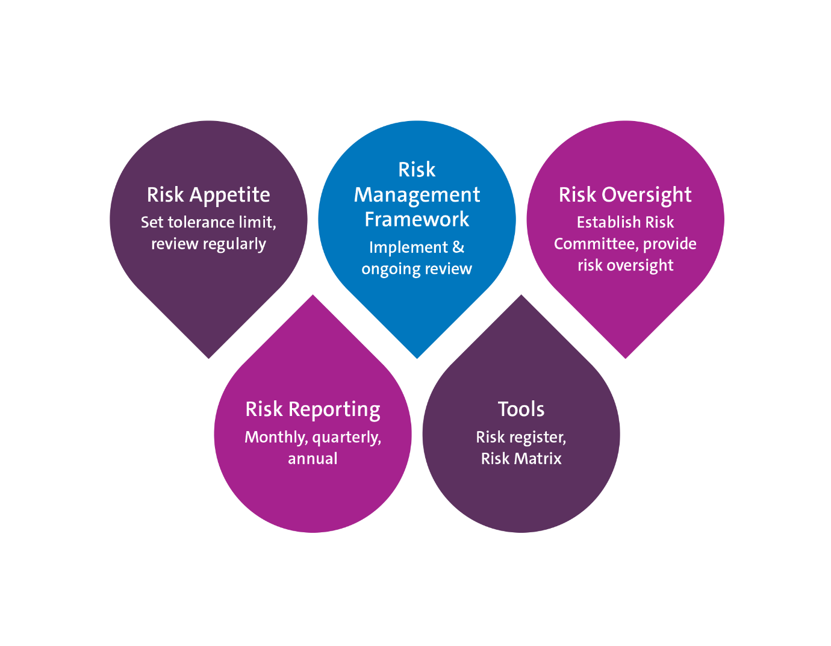

Risk Appetite

One of the most important roles of the Board in risk management is articulating the nature and the extent of risk the organisation is prepared to accept in pursuit of its purpose. This is often called defining or setting ‘risk appetite.’ The risk appetite provides parameters within which management can pursue the organisation’s purpose, and manage risks associated with it. It is critical that the organisation’s risk appetite is aligned with its purpose and growth plan to ensure the Board takes into consideration the need to accept some risk to achieve the planned growth. Striking a balance between being risk-averse and potentially overlooking opportunities for growth on the one hand, and disregarding risks completely in the pursuit of growth on the other, is critical to determining risk appetite and tolerance limits.

The challenge for Boards is in identifying and agreeing on the risks the Board is willing to take as a collective, and setting a tolerance limit for each category of risk identified, in order to provide management with clear guidance on what it needs to do to identify, assess and manage/mitigate the risks. Boards must ensure they engage in a collaborative process with the management and staff in formulating the risk appetite statement, and developing risk escalation and reporting protocols to ensure that they understand the risks and improve their reporting to the Board.

Risk Management Framework

The risk management framework is developed in line with the Board’s risk appetite, and incorporates procedures and processes including the following[16]:

* identification of risks
* determining the impact of the risks and developing strategies to minimise and/or manage them
* regular review and updating of risk registers
* ensuring that the risk culture of the organisation and its decision making is consistent with the risk appetite set by the Board
* monitoring and reporting to the Board how the risk management processes are being implemented in the organisation.

Key risks in the context of an EYM operating an early childhood service may include:

* *Compliance risks* such as changes in law and regulations, operational considerations in complying with laws and regulations
* *Child and family safety* such as injuries, accidents, safety from abuse, serious incidents etc.
* *Health and safety* such as injuries, hazards, infections, epidemic/pandemic management etc.
* *Operational or program risks* such as quality of service delivery; recruitment and retention of staff, business continuity etc.
* *Financial* such as cash flow, creditor and debtors, viability of the organisation, remaining solvent, infrastructure and investment decisions etc.
* *Brand and reputational risks*such as a lawsuit, negative publicity about the organisation or staff, serious injury to a child etc.
* *Strategic risks* such as increased competition, business growth, changes to government policy etc.
* *Governance risks*such as ineffective oversight, inability to attract board members etc.
* *Technology risks*such as IT infrastructure, maintenance and upgrades etc.

Risk Management Committee

Most organisations establish a risk management committee of the Board to create a greater focus on monitoring risks. In smaller organisations, it is common to have the risk oversight function added to the audit and finance committee. The ASX Corporate Governance Principles suggest that while ultimate responsibility for the risk management framework rests with the full Board, having a risk committee can be an efficient and effective mechanism to bring the transparency, focus, and independent judgement needed to oversee the entity’s risk management framework[17].

As with any committee of the Board, it is essential to have a clear charter or terms of reference setting out the role of the risk sub-committee, and the powers that are delegated to it by the Board to perform its role.

The ASX principles identify the following role for the committee:

* Monitor management’s performance against the risk management framework, including whether it is operating within the risk appetite set by the Board
* Receive reports from internal audit (if any) on its review of the organisation’s processes to manage risks and its adequacy
* Receive reports from management on new and emerging risks and the control and mitigation measures to deal with these new risks
* Make recommendations to the full Board in relation to any changes required to the organisation’s risk management framework, or to the Board’s risk appetite statement
* Oversee the organisation’s insurance program, having regard to the organisation’s business and the insurable risks associated with it
* Review any material incident involving fraud, mismanagement or breakdown of the organisation’s risk control and the lessons learned.

Reporting

Regular (monthly, quarterly and annual) reporting to the Board through the risk committee enables the Board to fulfil its responsibility to monitor the organisation’s risk management framework and satisfy itself that the organisation is operating with due regard to the risk appetite set by the Board. The Board must decide what level of detail is required in these reports.

Tools for operational oversight

A Risk Register (including Risk Matrix) documents all the risks identified by the organisation, level of risk and key controls and actions to limit the likelihood of an event.

A free Risk Register template can be accessed at [Our Community](https://www.communitydirectors.com.au/tools/risk-management-register-template).

Useful resources

* Our Community: [Main areas of risk for not-for-profit organisations](https://communitydirectors.com.au/help-sheets/the-main-areas-of-risk-for-not-for-profit-organisations)
* ASX [Corporate Governance Principles](https://www.asx.com.au/documents/regulation/cgc-principles-and-recommendations-fourth-edn.pdf).

## 1.10 Delegation of authority

In fulfilling this role as the governing body, the Board of an EYM may be authorised by its constitution to subdivide its powers and delegate them to employees or committees to achieve results. Despite such delegation, the Board holds ultimate responsibility for the organisation’s activities, and is accountable for the actions arising out of the delegation.

A formal decision of the Board is required to delegate powers or to revoke it. It is good practice to clearly define the extent of the authority the Board is delegating to a position or a committee, and the reporting that it requires from the delegate to enable it to monitor the proper exercise of the delegated authority. Terms of Reference are commonly used to define the parameters of the delegation, and the reporting requirements.

Careful consideration needs to be given to what powers are delegated and to whom. Common practice is to delegate powers to committees, the CEO of the organisation, individual board members for specific tasks/projects and to staff. In addition to delegating financial authority to ensure smooth day-to-day operations, Boards can also delegate authority to appoint employees, negotiate with external stakeholders, speak to the media on behalf of the organisation etc.

A delegation of authority may be for a finite time period until a task is completed, e.g. development of a new technology platform, or ongoing, e.g., Risk and audit committee charged with the oversight of the internal control and risk management functions. The Board has the authority to revoke a delegation it has made at any time it chooses to do so. Even where a delegation is in force, there is nothing that precludes a Board from exercising its authority in relation to the delegated matter, and make a decision itself.

Critical considerations in approving delegations include:

* the purpose for which the delegation is made; the need for the delegation and its adequacy in relation to the function to be discharged
* the presence of a policy and sound procedures under which the delegation will be exercised by the delegate
* the financial parameters within which the delegation is to be exercised, e.g., presence of a budget, limits of decision-making authority etc.
* delegating to a position and not an individual
* avoiding conflicts of interest, and personal benefits to the delegate arising from the tasks delegated.

Where there are standing delegations in relation to operational matters, such as financial and capital expenditure limits, employment of staff etc., it is also common practice to document the details of the delegation, limits for each position, and other conditions in a schedule of delegations. This schedule or chart will document:

* the function that is delegated (e.g., approving budgeted expenditure)
* the position(s) it is delegated to (e.g., Finance Manager $ limit, CEO $ limit)
* financial and/or decision-making limits (e.g., up to $xx if budgeted, $xx if unbudgeted)
* any conditions attaching to the delegation (e.g., circumstances under which special permission may be required for exercising delegations within prescribed limits).

Whatever method a Board adopts to define the transfer of its power, it is important to review the need for and adequacy of the delegation at least annually to ensure it is up-to-date, and supports the effective functioning of the organisation.

Useful resources

The Institute of Community Directors Australia (Our Community): [Template delegations policy and procedures](https://communitydirectors.com.au/policies/delegations).

# D. Planning and Stewardship

## 1.11 Strategic Planning

A strategy is a plan of action designed to achieve an organisation’s long-term goal, and is aligned to its vision, purpose/mission and values. Strategic planning is a process by which an EYM organisation can define its future directions, usually 3 to 5 years, in the context of the environment in which it currently operates both internally and externally, and the changes it anticipates in these environments in the future.

This strategic planning process results in a set of clearly articulated actions, how the organisation proposes to achieve its goals, the timeframe within which it aspires to achieve each goal, the resources it will allocate, and the indicators which will demonstrate whether a goal has been achieved. It is different to an operational plan which determines what the organisation will do to get there. It sets goals/priorities, focuses resources to achieving those goals/priorities, strengthens operations, ensures staff and stakeholders work towards common goals, and importantly establishes agreement on outcomes and results.

In Victoria, EYMs are accountable to various stakeholders for their effectiveness in improving outcomes for children. In particular, the EYM Outcomes and draft Performance Framework[18] is the key Victorian Department of Education and Training (DET) tool for measuring the performance of an EYM. EYM outcomes detailed in the Framework are:

* Sustainable and responsive services
* Access and participation
* Quality and innovation
* Highly skilled, collaborative workforce; and
* Strong partnerships

The following information on the Strategic Planning Process should be considered in conjunction with the EYM Outcomes and draft Performance Framework, as it sets out the outcomes, activities and measures that track the impact of an EYM in achieving improved outcomes for children. The vision of the Framework is EYM as the leading platform to achieve improved outcomes for all young children, through the delivery of world-class, accessible early childhood education and care services.

The Board’s role in setting strategy

The Board’s main role is to set the strategic direction for the organisation with consideration given to risk appetite. The extent to which the Board is involved in developing a strategic plan varies significantly depending on various factors including size, skills of management team etc. It is not uncommon for Boards of not-for-profit organisations to both set strategy and be involved in the development of the strategic plan in collaboration with the management team.

The final approval of the strategy must rest with the Board.[19] On an ongoing basis, the Board must ensure that management develops operational plans to implement the agreed strategy and must have mechanisms in place to regularly monitor the implementation of the plan and the outcomes it is achieving.

The following are some questions that a Board may ask itself and of management in relation to setting the organisation’s strategy[20]:

* What is the strategic intent?
* Have we considered all options?
* Have we thought ‘left field’?
* What are our cost constraints?
* What is our position relative to our competitors?
* What can we learn from other organisations?
* How can we be more innovative?
* Do we have the capacity (for example, human and financial capital) to implement our strategy?
* Is the strategic plan considering what we need to do in the short, medium and long-term?

Strategic planning process

A best practice strategic planning process will involve consultation with the organisation’s stakeholders – the Board, staff, community members as well as external stakeholders such as funders, other service providers in the local area, and the local council. There are many different models and action steps for strategic planning; however, most organisations typically work through similar steps. One possible approach is described below.

#### Step one: Agree on a strategic planning process

There is no right or wrong way to undertake strategic planning, so the process can commence by determining what resources and time might be required to develop the plan, and the tools and approaches that might be used. For example, organisations might decide to set up a ‘strategy team’ or a ‘strategy committee’ to lead the process and present options for consideration by the Board. Alternatively, they might opt for a strategic planning day or weekend with the Board and senior staff, and have an independent facilitator guide them through the process of reviewing the performance against the previous strategic plan and actions for the next plan period.

We strongly recommend that an EYM Board establishes a Strategic Planning committee to lead, oversee and coordinate all stages of its Strategic Planning process. The coordinating group can include a mix of Board members and senior staff and representatives from the Parent Advisory Groups (PAGs)[21]. Consultation with representatives of stakeholder groups such as local council may also be included if active participation from a wider group of stakeholders is desired.

#### Step two: Conduct an environmental scan

An environmental scan helps the EYM organisation gain an understanding of its internal and external environments and their impact on its future. The scan usually includes an external component - identifying and assessing opportunities and threats and an internal component - assessing organisational strengths and weaknesses. This process, often referred to as a SWOT analysis, is a common activity undertaken in the planning process.

##### SWOT analysis

* Strengths – the attributes and factors helping an organisation achieve its mission
* Weaknesses – the factors that are weaknesses, barriers or constraints for the organisation
* Opportunities – the factors or options that could strengthen the organisation and help it achieve its mission
* Threats – the factors that could be obstructive or threaten organisational growth and/or sustainability.

A SWOT analysis can help the Board and management consider the enablers and barriers that may impact on the growth and development of the organisation, and make better strategic choices and decisions about the organisation’s operational and financial direction for the next 3-5 years.

The following activities can help inform the SWOT analysis and the strategic planning process in an EYM organisation:

* Collate and analyse past performance information. For example:
  + meet with the DET Regional representative and Local Council liaison person(s) and seek feedback and information on their future priorities
  + Review the organisation’s Service Improvement and Quality Improvement Plans and note progress
  + Review enrolment data and financial performance in the last two to three years, and identify any trends
  + Review staffing data and staff survey results if any for the past couple of years and identify key emerging themes
  + Collect any available user survey data for the current and previous year
  + Meet with the PAGs of the kindergartens to better understand the needs of each local community
* Collect and analyse broader early childhood data such as:
  + the AEDC data for the region and local areas where the kindergartens are located
  + population projections for the local areas
  + Municipal Early Years’ Plan that the local Council has developed
  + DET surveys and EYM performance data for the State, region and the individual services etc., to provide context to your planning
* Undertake an external scan of the key trends and macro factors that may impact on the organisation and the services delivered, e.g., Government Policy directions, regulatory changes at State and National levels etc.
* Consider competition and other factors that may impact on the organisation’s viability and sustainability into the future, and the service offerings
* Consider existing and new partnerships that could strengthen the EYM’s value in the community.

Share the above information with the team that is engaged in the strategic planning process to ensure they are familiar with the background information before strategic decisions are made.

#### Step three: Develop the Strategic Plan

Develop the plan taking into consideration all of the information gathered in the previous stages for this process. Once agreed, document the plan clearly, review the document following the organisation’s process for reviewing key documents. Incorporate changes if any from the review process and finalise the plan for approval by the Board.

A Planning Template_Strategic_Plan) has been included that outlines the key activities to develop a strategic plan. EYMs who wish to develop their strategic plan in-house may find this template a useful guide. Please note, the template is provided for guidance purposes only and organisations can choose to develop their own templates or tailor the template to suit their specific needs.

#### Step four: Approve the plan

The authority to approve the plan rests with the Board. Once approved, it becomes the blue-print for the organisation’s activities for the duration of the plan period, and is the basis on which management develops its annual operational plans to achieve the goals and objectives set.

#### Step five: Publish/share the plan

A strategic plan is an important document that should guide the day to day actions and decisions of staff. It is therefore essential for organisations to have an internal communication strategy in place to ensure all staff are aware of the plan, have access to it, are inspired and motivated by it and use it on a regular basis.

A well-written strategic plan is also an effective marketing tool that informs key stakeholders about the organisation, and its future goals and focus. Once approved by the Board, organisations can choose to share the plan publicly, e.g., through their website. The level of detail that is shared in the public domain is a matter of individual preference, depending on several factors such as competition, sensitivity of the information relating to resources etc. A summary of the plan and key priorities can be prepared to be made public.

#### Step six: Monitoring and reviewing the Strategic Plan

A strategic plan is a “living document” meaning, it must be capable of being adjusted if necessary, according to changing conditions and needs. Building a review cycle within the strategic planning process (annual, or six-monthly if required) ensures that organisations can reflect on their progress and adjust the goals/strategies as necessary, to ensure the document stays relevant.

The Board plays a critical role in monitoring progress made by the organisation against the strategic plan, and approving changes that may be required as appropriate. It is common for management to report to every Board meeting progress against the strategic plan.

### a) Strategic Plan Template

This template provides a suggested structure for a strategic plan, and guidance in addressing the criteria to complete each section. Please note, the template is provided for guidance purposes only and organisations can choose to develop their own templates or tailor the template to suit their specific needs.

| Plan structure | Content | Description |
| --- | --- | --- |
| Introduction | Vision, Mission/Purpose, values, service philosophy | Most EYMs may have:   * a vision and mission/purpose statements setting out the change it is seeking to create by providing services, and how it will achieve this change * a set of defined values and principles, articulating the basis of its internal and external interactions * a service philosophy that defines its approach to delivering its early learning programs.   The strategic planning process provides an ideal opportunity to review these documents to ensure they are relevant in the current context, and is best done as part of a planning workshop involving participation from Board members and senior staff. |
| Context / Environment | Define the environment or the context in which the organisation operates. | A brief overview of the results of the environment scan undertaken for the planning process can be included in this section, to provide context to the strategic plan and goals set.  The consultation process that the EYM undertook to develop the plan, and the stakeholders it consulted with can also be included in this section. |
| Strategic priorities | A high-level definition of the priorities that the organisation will focus on during the plan period. | These statements are best kept at a high level, setting out the priority areas that the organisation has decided to focus its efforts and resources on over the next 3-5 years. They should be concise and specific and lead into the next section where specific goals within each priority area are described. |
| Goals | A statement of the outcomes/results that the organisation is seeking to achieve in each of the priority areas identified during the plan period. | The goals may be developed using the SMART principle – Specific, Measurable, Achievable, Results-based and Time-defined, to enable successful implementation and measurement.  To facilitate better measurement of progress against goals, they can also be broken down and set out to show what the organisation is seeking to achieve in each year during the plan period. |
| Actions | Define the key activities or actions the organisation will implement to achieve the goals. | Actions that the organisation will take must be defined carefully taking into consideration the following:   * The value the action will contribute to achieving the goal * Its appropriateness in the context of the organisation’s vision, mission/purpose, values and principles * Its feasibility given the organisation’s capacity and resources * Its acceptability to the Board, staff, families and stakeholders * The timing, and whether it can be achieved during the plan period. |
| Timeframe | Specify the timeframe for the achievement of each goal within the plan period, e.g., by the first year, the second year etc. | Strategic plans usually span 3-5 years and care must be taken to ensure that the tasks are spread reasonably over this period, leading gradually to the achievement of the goals.  This will also ensure that staff who have the responsibility to implement the tasks are able to accommodate the new demands on their time with their other ongoing work (‘business as usual) and don’t feel overwhelmed. |
| Measure | A definition of the measure of the change that is being achieved as a result of the actions. | This is a measure of the outputs that will let everyone know whether the actions have resulted in the anticipated outcomes. For example, if   * a **strategic priority** is to grow the organisation’s footprint * the **goal** associated with it is to increase the number of kindergartens under the EYM’s management; and * the **actions** to achieve the goal is to market the EYM to existing stand-alone kindergartens in the area, bid for new services etc; and * the **timeframe** to achieve this is within the next two years; then * the **measure** would be to specify the number of additional services that the EYM brings under its management.   The success or failure of the actions will be measured by this definition, and care must be taken to ensure it is realistic, and achievable. |
| Monitoring and review | Briefly describe the organisation’s commitment to review this plan during the plan period. | Specify how the organisation plans to monitor and review the plan, and the process that will be implemented to achieve this. |

## 1.12 Board work plan

A Board workplan is a useful tool that helps a Board to focus on its various responsibilities at different times during the year. It is normal practice in many organisations to develop this plan in the form of an annual Board calendar, setting out the dates and times when the Board and the various committees meet, the date of the Annual General Meeting, and Strategic planning/review day.

EYM Boards can also use this calendar template to add other critical Board compliance or monitoring tasks to ensure that at the appointed time, the matter is included in the Board agenda and attended to. A strong Board calendar is a valuable planning tool that helps to ensure nothing is overlooked, provides a focus for Board meetings and minimises repetitive discussions at meetings[22].

Examples of other tasks that can be included are:

* CEO performance oversight
* Review of policies
* Evaluation of Board performance
* Review of Board composition and skills
* Key regulatory and compliance dates

Useful resources

Australian Institute of Company Directors: [Annual board calendar](https://aicd.companydirectors.com.au/~/media/cd2/resources/director-resources/director-tools/pdf/05446-4-1-director-tools-me-board-calendar_web.ashx).

# E. Performance assurance

## 1.13 Board evaluation

Evaluating the performance of the Board and individual members of the Board is an essential but often overlooked aspect of governance. In 2014, the ASX recommended in its Corporate Governance Principles and Recommendations that listed companies ‘should have and disclose a process for periodically evaluating the performance of the Board, its committees and individual directors’[23]. A similar requirement from the Australian Prudential Regulation Authority (APRA) that Board performance and individual director performance must be reviewed at least annually has ensured that from 2015, major corporates have made the evaluation of their board and individual directors an ongoing element of their governance practice.

In the not-for-profit sector Board positions are voluntary. The perception has been that the governance standard in this sector need not therefore be the same as what is required in the commercial sector, where Board members receive a remuneration. This perception is changing, and more and more not-for-profit organisations are embracing the concept of evaluating the performance of their governing body and its members individually. ELAA strongly recommends rural EYM Boards to implement a process to evaluate their performance.

Purpose of evaluation

The purpose of evaluating the Board’s performance is to assess how much value the Board collectively, and its individual members are adding to the organisation they govern. Board evaluation is a means by which Boards ensure that they have the right skill mix, are leading the organisation appropriately and individual members are effective in fulfilling their obligations to the board and the organisation. Board evaluations are effective only when its members undertake it with the genuine intention of understanding the impact of their leadership on the organisation, rather than as a mechanical process to meet a compliance requirement.

Benefits of evaluation

Boards that reflect on their own performance and practices in a meaningful way are better able to support organisational performance, by learning from past experience and looking to their future development. The benefits[24] can be across a range of areas such as:

* leadership – understanding and setting the right tone and culture from the top, and demonstrating commitment to improvement at the individual level
* role clarity – understanding and establishing a clear distinction between governance and management, clarifying duties of individual members, expectations etc.
* teamwork – building trust, encouraging active participation from all members, creating a sense of ownership
* accountability - better delegation, improved governance standards, focusing attention on duties towards constituent members, improving individual member’s understanding of their duties and responsibilities, setting performance expectations
* decision-making - identifying issues and improving decision-making, identifying skills gaps, improved utilisation of board members’ skills
* communication - improving Board and CEO/management relationship, trust between Board members, understanding and improving stakeholder relationships etc.
* Board operations – ensuring sound governance policies, efficient meetings and effective use of time, improved individual contributions.

A framework for evaluation

A framework for Board evaluation developed by Keil, Nicholson and Barclay[25] suggests seven key questions to determine the scope, complexity and the costs of undertaking a Board evaluation.

|  |  |
| --- | --- |
| 1) What are our objectives? | Clearly identify what the Board hopes to achieve through the evaluation, and define its scope. Identify what financial commitment the Board is prepared to make to undertake the evaluation. |
| 2) Who will be evaluated? | Determine who is being evaluated - the Board as a whole including all its committees, individual directors, key governance personnel from the organisation etc. |
| 3) What will be evaluated? | Determine the themes that will be addressed in the evaluation e.g., collective performance of the board, performance of individual members, board processes, competencies/skills, relationships etc. |
| 4) Who will be asked? | Identify who will be asked to provide feedback for the evaluation (e.g., Board members, CEO, senior managers, other stakeholders etc.). This will be informed by a decision on the theme of the evaluation, and hence, the people or groups that may have the best knowledge to provide an assessment. |
| 5) What techniques will be used? | Determine the technique that is used to collect information to inform the assessment. Surveys, interviews, observations, and analysis of documents are some of the techniques that can be used in a Board evaluation either by themselves or in combination. Peer reviews where Board members rate themselves and their colleagues can also be used to assess individual member performance.  The technique that is chosen needs to be appropriate for the objective of the evaluation. |
| 6) Who will do the evaluation? | Determine whether the evaluation will be done internally e.g., by the Chairperson or a committee, or externally by engaging a consultant. The choice will ultimately depend on the level of independence sought in the reviewer, and the audience for the results. |
| 7) What will you do with the result? | Consider whether the results of the evaluation will be shared, and if so, with who? Depending on the objective of the review, the Board may decide to share and discuss results among themselves, with individual members, or share it more broadly with the senior management team. |

Important considerations

The following are some important considerations for EYM Boards to keep in mind when considering an evaluation:

* The relationship between the Board and the CEO and senior management is critical for its performance, and from an operational perspective, they may be able to identify governance issues that the Board may not be aware of. ‘Without input from executives, a board evaluation amounts to pure self-assessment by directors. Hence management involvement ought to be encouraged, especially since Board/management relationships are one of the most important contributors to an effective Board’[26]
* As with any reflective exercise, maximum benefits from the evaluation can be derived if all the members of the Board collectively believe in the exercise and its ability to help them improve their performance
* Trust in the process, constructive feedback and assessment, and confidentiality are important for the success of an evaluation
* To ensure a smooth process, the Chairperson must be prepared to lead the exercise, and manage the process
* A considerable investment in time and effort (and funds if seeking external support to conduct the evaluation) is required of the entire Board to undertake a comprehensive evaluation. An EYM Board may consider undertaking a formal evaluation to coincide with the strategic planning cycle, and have other measures in place to ensure continuous evaluation in the interim period
* The Board must be committed to an action plan with specific measurable KPIs to address areas identified for improvement through the evaluation. It is important that the Chair, or a committee, is delegated the responsibility to oversee the plan’s implementation. The Chair has a critical role to play in counselling individual members where improvement needs or concerns have been identified.

Evaluating performance in regular Board meetings

It is now common practice for Boards to evaluate their effectiveness in regular board meetings. Typically, the agenda includes an ‘in camera’ discussion time at the end of the meeting to allow members to provide constructive feedback on how the meeting was held, the quality of the discussions, opportunities for participation, the effectiveness of the agenda and the papers that were provided to the Board in preparation for the meeting. This is a continuous improvement process which supports effective Board functioning and addresses improvements required in a timely manner, rather than wait for a formal evaluation process. EYM Boards may consider incorporating this practice in their regular Board meetings.

Useful resources

* Australian Institute of Company Directors: [Board Evaluation](http://www.companydirectors.com.au/Director-Resource-Centre/Publications/Company-Director-magazine/2000-to-2009-back-editions/2007/May/Board-Evaluation)
* Australian Institute of Company Directors: [Board evaluation and Director Appraisal](http://aicd.companydirectors.com.au/-/media/cd2/resources/director-resources/director-tools/pdf/05446-2-1-director-tools-bp_board-evaluation-director-appraisal_a4_web.ashx)
* Geoffrey Kiel and James Beck: [Seven steps to effective board and director evaluations](https://www.effectivegovernance.com.au/wp-content/uploads/2012/10/Seven-steps-to-effective-board-and-director-evaluations-Beck-and-Kiel.pdf).

# F. Participation and empowerment

## 1.14 Communication and engagement

### a) Mapping stakeholders

The EYM Policy Framework is built on a four-way partnership model, where the four partners – families, EYM organisations, local government, and the Department - work together to deliver a quality early education experience for all children[27]. The creation of a formal communication and stakeholder engagement strategy supports the work of the Board and the EYM organisation to further this partnership and inform and engage stakeholders to achieve optimal outcomes. Each of these partners has a role to play within this system, which provides a measure of the need to communicate and strategies for communicating with them.

EYM organisations link with sector partners to maximise the participation of all children. This can mean being part of local government central registration and enrolment processes (where available) and working closely with other services (e.g. Child FIRST) to proactively identify children that might miss out on established enrolment processes.

Stakeholder mapping is an essential first step to developing a communication and engagement strategy for an EYM organisation. Based on the EYM Framework, the following key partners and stakeholders are already identified:

* Families and PAGs
* Local Government
* DET
* Local schools
* Other early childhood services e.g., Maternal and Child Health
* Other community services in the local area, such as supported playgroups, Orange Door and Child FIRST.
* Other EYM organisations
* Staff at the services.

EYMs can build on this list and add more stakeholders that can influence or impact on its service delivery and support the organisation to deliver high quality kindergarten services in line with the EYM Outcomes.

#### Families (the Parent Advisory Group)

In developing a communication and engagement strategy with families and the PAG, the EYM organisation can be guided by the role of the PAG articulated by the Department in the EYM Framework. This framework sets out the role of a PAG as facilitating feedback to the EYM, from families accessing the kindergarten regarding the following[28]:

* the objectives of the kindergarten and EYM organisation
* the development of kindergarten policy, where appropriate
* decisions that affect opportunities for families to be involved in a kindergarten program
* development and delivery of the kindergarten program and service delivery, and notifying any community issues or concerns to the EYM organisation
* input into the future planning of the service
* negotiated roles, like fundraising.

Regular communication with and facilitating positive engagement of the PAG in various aspects of the EYM’s planning process, and decisions that affect the kindergartens they represent will strengthen the partnership as articulated in the EYM Policy Framework. EYMs can also consider including PAG representatives in the strategic planning process, regular consultation with PAG members on service-related matters, attendance at PAG organised events etc., as a means of empowering parent representatives and strengthening the partnership to deliver effective services.

#### Local Government

Local Government plays a key legislated role in strategically planning and coordinating early years services within a municipality. Its responsibility for local area planning includes the development of the Municipal Early Years Plan (MEYP) which provide strategic direction for coordinating educational, care and health programs, and activities within the municipality that affect children from birth through kindergarten until they enter school[29].

Many local government organisations also provide early years facilities and services and undertake the role of an EYM organisation.

Local governments engage with EYMs in several ways, principal among them being in their planning role through exchanging data and information relating to enrolments, capacity and utilisation. Many local governments operate central registration and enrolment schemes that EYM-managed services are expected to be part of, where available. Where an EYM organisation operates a kindergarten service out of a council-owned facility, they will engage with the EYM as the landlord of the premises.

Local governments may extend professional development opportunities to kindergarten staff and have a role in endorsing the setting up of a new EYM and adding a new service to an EYM.

There is a clear expectation from DET that though the models of engagement and the relationship between a local government and an EYM can be different across the State, it expects an EYM and the local government to collaborate strongly in planning and coordinating the delivery of early years’ services.

#### The Department

DET plays multiple roles in relation to an EYM, including:

* a stewardship role in service planning and policy development, funding, performance/outcome monitoring, and operational guidance
* an assessment role in relation to quality assessment and NQF support
* a development and facilitation role through state-wide forums providing opportunities for reflection on practice and research and sector consultations on strategic issues.

The principal engagement that EYMs have with DET is through the Regional DET offices, on matters such as funding and oversight of the service, health and safety, emergency management, workforce development, incident notifications etc.

From time to time, EYMs are also called upon to contribute their expertise to state level reference and advisory groups on policy-related matters.

#### Other stakeholders

Other stakeholders – internal and external – with whom an EYM is required to work in partnership in delivering the service include staff, local schools, other early childhood organisations and family and community services in the local area. With local governments increasingly shifting towards an integrated model of service delivery in the early years with a community development approach, partnerships with these stakeholder groups is a critical component to ensure that families and children have access not only to a high quality early childhood program, but also to wrap around support services to help vulnerable families. Transition to school can be seamless if kindergartens and schools work together to support children and families at this critical milestone in their lives.

### b) Developing a communication and engagement strategy

#### Step one: Assess/analyse

In this step, the level of interest of each stakeholder group in the EYM organisation and their influence need to be determined. This will determine the effort that is required to communicate and engage with the group and the model of communication that will be effective in gaining engagement.

* **Interest** – How important is the EYM organisation to the stakeholder? How much are they affected?
* **Influence** – Do they have the ability or power to influence the EYM organisation – positively or negatively?

Depending on the level of interest and influence assessed for each stakeholder group, they can be grouped into the following categories, and the effort an EYM puts into engaging and communicating can be tailored to suit each category:

* High influence, low interest
* High influence, high interest
* Low influence, high interest
* Low influence, low interest.

The examples provided in the table below are indicative only and EYMs are encouraged to undertake this assessment in the context of their own circumstances, and the local environment in which they operate.

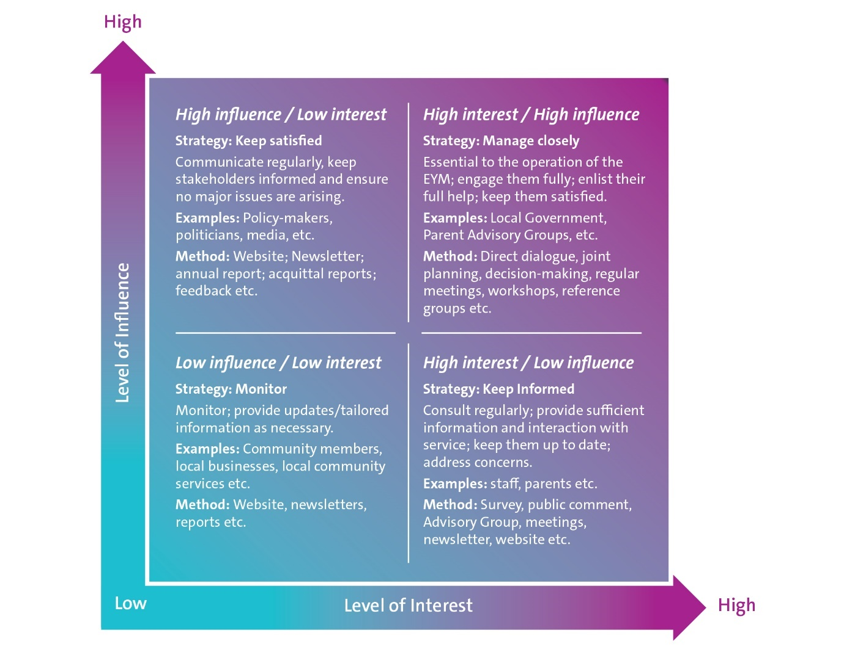

#### Step two: Determine key messages

Having assessed and determined the most effective method to engage and communicate with the stakeholder group, the next step is to determine the key messages that need to be communicated/shared with the respective stakeholder groups that meet their specific needs.

#### Step three: Nominate responsible person and set implementation timelines

The final step is to determine the person who will be responsible for the engagement with the stakeholder group and timelines if any to achieve the communication/engagement.

#### Step four: Implement and monitor

It is the responsibility of the management to implement the engagement and communication plan and the Board’s responsibility to satisfy itself that it is being implemented appropriately.

Useful resources

International Association for Public Participation: [Public Participation Spectrum](https://www.iap2.org.au/resources/spectrum/).

1. This assessment incorporated a review of governance documentation, discussions and a survey of the CEO and a Board member of the participating organisations
2. The Kirby review 2001, the KPMG review 2009 and the North Eastern Victorian Region Cluster Management Governance Project 2016
3. <https://aicd.companydirectors.com.au/-/media/cd2/resources/director-resources/director-tools/pdf/05446-3-9-mem-director-gr-position-description-chair_a4-web.ashx>
4. Governance Institute of Australia, Good Governance Guide: Creating and disclosing a board skills matrix
5. Source: Kiel, G., Nicholson, G., Tunny, J.A., & Beck, J., Directors at Work: A Practical Guide for Boards, Thomson Reuters, Sydney, 2012, tailored for EYMs
6. The Executive of the Board usually comprises the ‘Office Bearers’ such as the Chair/President, Vice-Chair/Vice-President, Treasurer and Secretary
7. AICD, 2020, Director Tools: Organisation – Board Charters
8. Ibid, p4.
9. ASX Corporate Governance Council 2019, Corporate Governance Principles and Recommendations, 4th edition
10. Keil, G., Nicholson, G., Tunny, J. A. & Beck, J., 2012, Directors at Work: A Practical Guide for Boards, Thomson Reuters
11. Please note that these links were current at the time of developing this manual in March 2020
12. <https://communitydirectors.com.au/tools-resources/policy-bank>
13. Committee of Sponsoring Organisations of the Treadway Commission, 1992, Guidance on internal control
14. COSO, 2013, Internal Control – Integrated Framework, Executive Summary, p3
15. AS/NZS ISO 3100 Risk management
16. AICD, Director Resources: Risk Management
17. ASX Corporate Governance Council, 2019, Corporate Governance Principles and Recommendations, 4th edition, p29
18. Department of Education and Training, Early Learning Participation branch, *EYM Kindergarten Operational Guidelines*, Appendix 1: EYM Outcomes and Draft Performance Framework, p33-38.
19. Australian Institute of Company Directors, Director Tools: Organisation – Strategic Plan and Development, p2
20. Australian Institute of Company Directors, Director Tools: Organisation – Strategic Plan and Development, p3
21. This is one way of ensuring that the requirement in the EYM Framework to include parents in the board decision-making process is met
22. AICD, Director Resources: Director Tools: Annual Board Calendar, *Meeting Effectiveness,* p1
23. ASX Corporate Governance Council, 2014 Corporate Governance Principles and Recommendations, 1.6(a)
24. Company Secretary, Keil G, Beck J, Seven Steps to effective Board and Director evaluations
25. Kiel, G C, Nicholson, G J, and Barclay, M A, Board, Director and CEO Evaluation, McGraw-Hill, Sydney, 2005, p 17
26. AICD, Director Tools: Board Performance – Board evaluation and director appraisal, p3
27. Department of Education and Training, 2016, EYM Operational Guidelines
28. Department of Education and Training, 2016, EYM Policy Framework, Part 1, P21
29. Ibid, p27, 28