Introduction
The Best Start, Best Life reforms give Victorian children access to 2 years of quality kindergarten, regardless of their life circumstances, background, or postcode.
The materials provided in this kit will help you promote Free Kinder, Pre-Prep and the Best Start, Best Life reforms. Use the content to suit your channels by tailoring the messaging as needed.
You can share the following posts on your social media channels (e.g., Facebook, Instagram or X/Twitter).
Don’t forget to follow and tag us.
- Instagram @earlychildhoodvic
- LinkedIn @DepartmentOfEducation
- X @VicGovDE

Videos
Consider sharing these videos in your online communications:
- Three-Year-Old Kinder on Vimeo
- 2025 Kinder Enrolments
- Make everyday a new adventure – YouTube

Digital assets
The table below lists the available assets. Click on the text in the Type column to download the content for use on your channels.
Type | Asset
Social media 1_2025 enrolments | 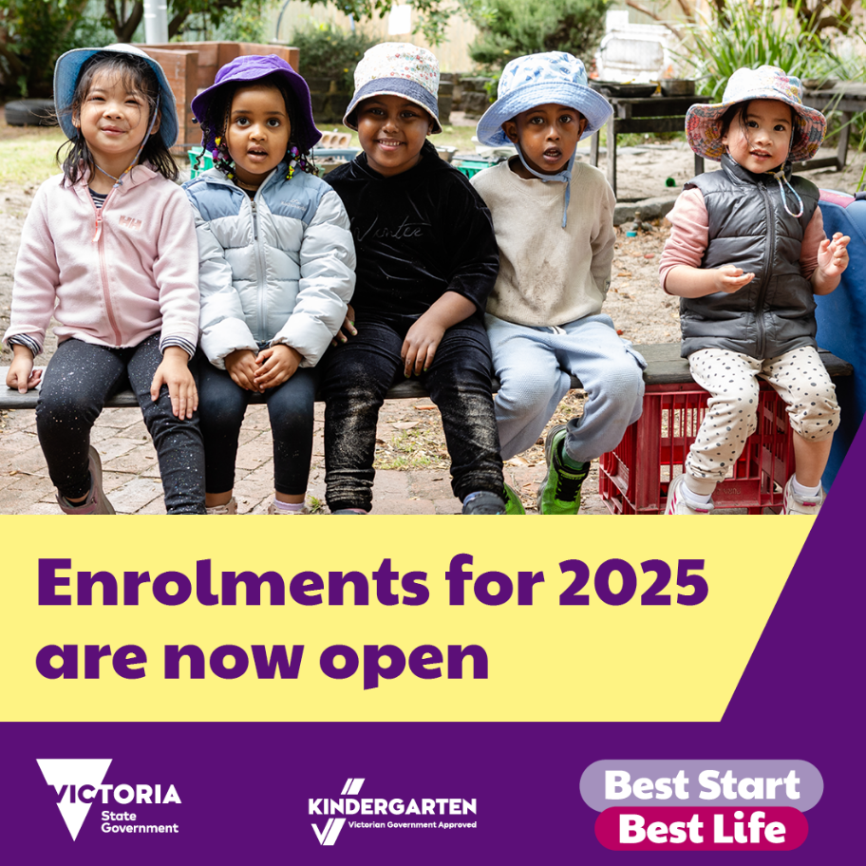
Social media_benefits of 2 years of kinder | 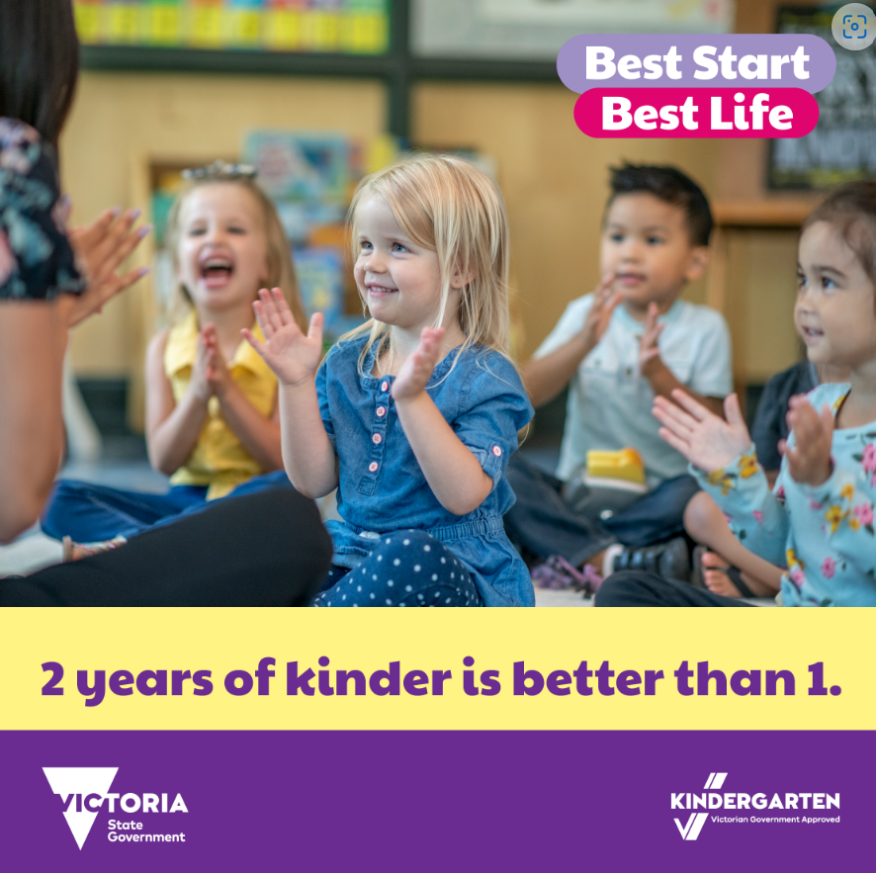
Social media_Free Kinder for 3- and 4-year-olds | 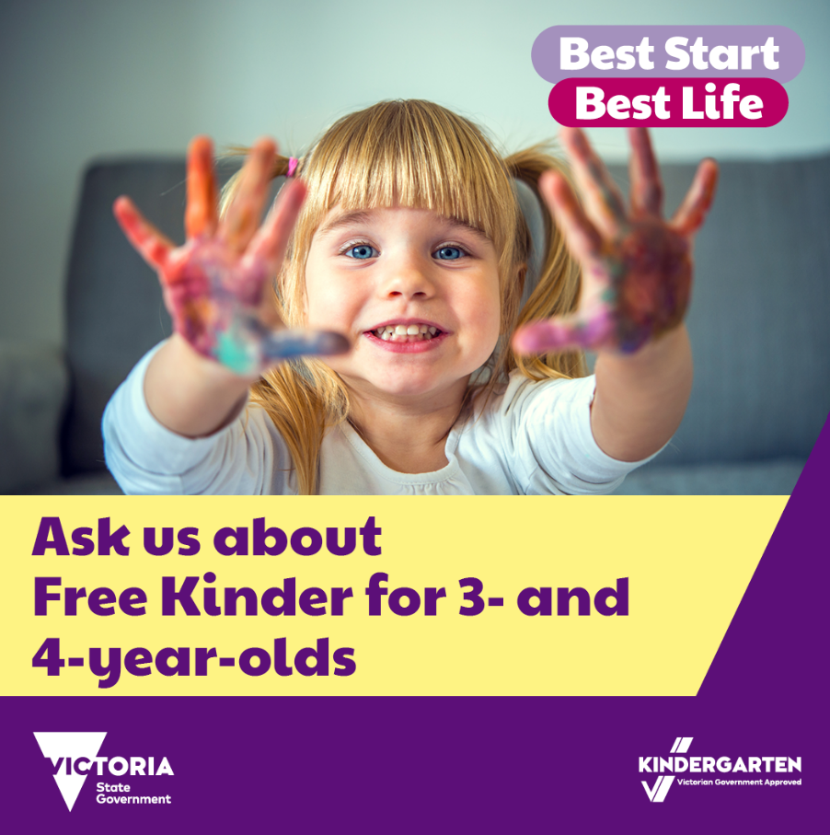
Three-Year-Old Kinder Poster | 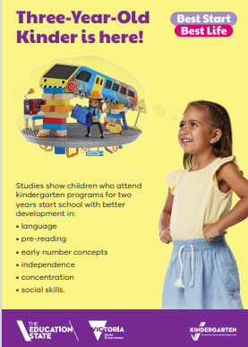
Postcard_Know someone with a two-year-old | 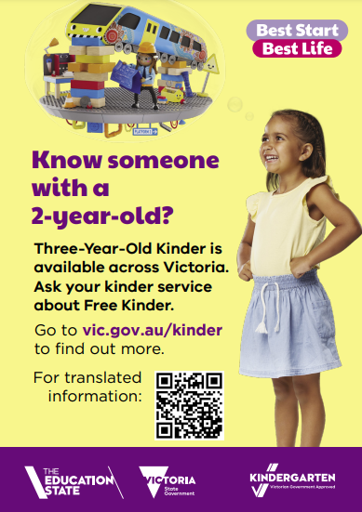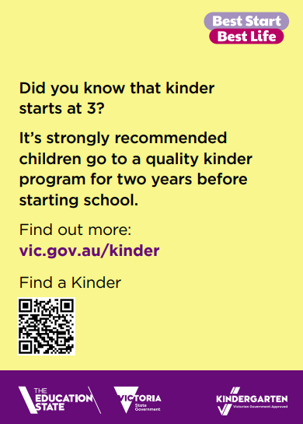
Pre-Prep 2025 GIF – available in the shared zip file | 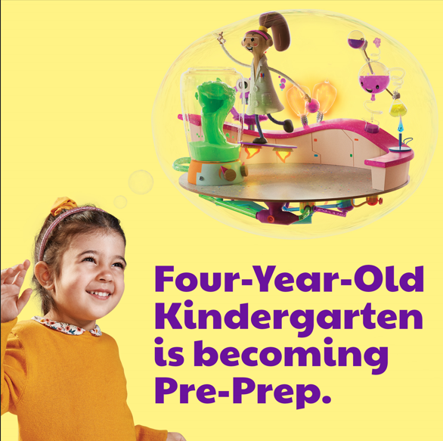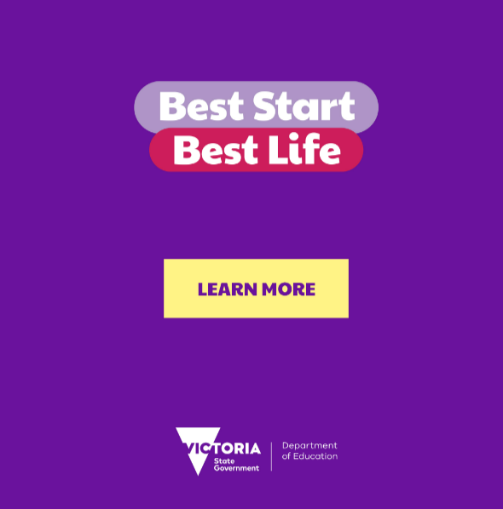
Pre-Prep Rollout Map | 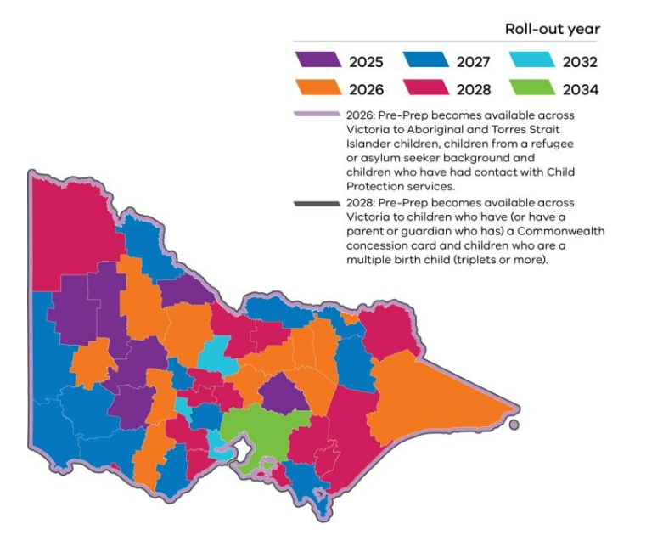
Pre-Prep_Social media map | 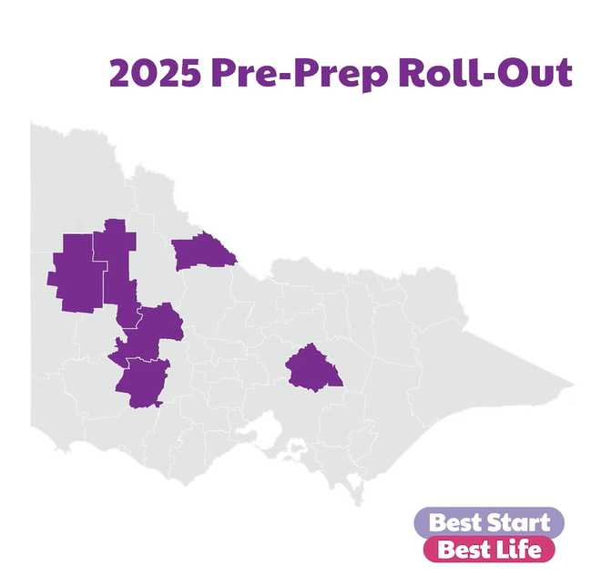  Pre-Prep GIF

